https://www.readandspell.com/us/visual-processing-disorders

Visual processing disorders
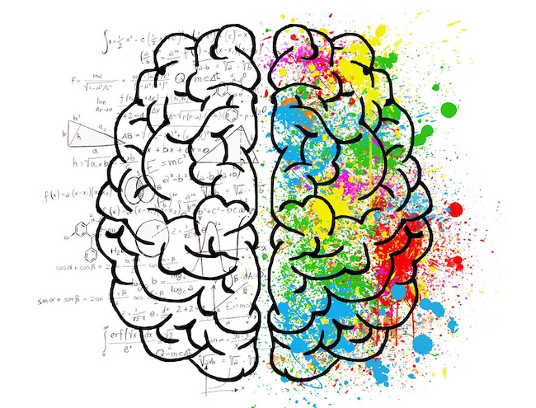
Visual processing disorders occur when the brain has trouble making sense of the visual input it receives. They are distinct from visual impairment in that there is no blindness or issue with the functioning of the eyes. A child may have 20/20 vision and pass a sight test with flying colors but still be unable to distinguish between two objects or make sense of the symbols on a page.
Difficulties can manifest in a number of ways and no two children will face the same challenges. Some may have trouble judging distances, whereas others will struggle with the ability to assess color, size and orientation.
Spatial processing and coordination can be problematic and a child might easily become lost and disorientated or struggle with fine and gross motor skills.
Given much of the information students learn in a typical classroom is received through the eyes, visual disorders often impact on learning. Students may have trouble focusing and be easily distracted by too much input in their field of vision. They can struggle with physical education, art, music and sports, and reading and writing can also be severely impacted.
Shapes and symbols may be confused because of their orientation or the underlying whole/part relationships. For example, a child may focus only on the individual letters that make up a word or alternatively see only the word itself and not its component parts.
They may find themselves re-reading the same sentence many times or getting lost on the page. However, unlike dyslexia, issues with reading and writing are not related to phonemic awareness deficits.
Visual processing disorders can also affect life skills, such as remembering phone numbers or following directions. For all of these reasons, it’s important to identify visual issues as early as possible and ensure a correct diagnosis is made. With the right strategies and accommodations, every child can realize his or her full potential at school.

Different kinds of visual difficulty
Recognizing and interpreting visual stimuli is a complex function undertaken by the brain and visual processing disorders range greatly in their severity and the aspects of perception they affect. A child may present with one or more of the following:

Spatial difficulty
Defined as difficulty processing the location of objects and symbols in relation to each other, symptoms may include directionality issues, such as reversing and confusing letters and numbers with similar shapes. This impacts on reading skills but can also affect performance in math.

Visual discrimination
Being able to identify an object from an image and/or to distinguish between objects of a different colour, size, shape and positioning are skills the child may struggle with.

Visual agnosia
A child who struggles with visual discrimination may also have trouble recognizing and naming objects and symbols consistently. This can be problematic in math and reading lessons and is often helped by taking a multi-sensory approach to learning.

Visual closure
If a child is unable to see 100% of an object the brain typically fills in the missing bits using prior knowledge. However, for children with this type of visual processing difficulty, the object may remain unidentifiable and cause comprehension issues and confusion. Generating a mental image for use in mnemonics can also be difficult.

Visual motor integration
When visual processing disorders affect motor skills it can make it hard for a child to participate in sports because hand eye coordination is often lacking.

Whole/part issues
Discriminating the visual details that signal whole and part relationships may be problematic. For example, fitting together a puzzle can be tricky as the child may not recognize how pieces are related to each other.

Classroom accommodations
There are treatments for visual processing difficulties but it’s also important to implement a set of classroom accommodations to prevent children from falling behind. Because no two students will have the same set of symptoms, each approach should be customized for the individual child.
- Repeat information in different modalities. Important information such as task instructions should always be delivered in more than one modality. Teachers might want to say the instructions out loud, demonstrate them and provide a handout. This is good practice in general as it will ensure students with different learning styles and preferences are all given an equal opportunity to prepare for the lesson.
- Provide thickly lined or dotted paper for writing. This can make it easier when writing by hand is required. It’s also helpful for students who struggle with dysgraphia and dyspraxia.
- Set tasks that require multi-sensory feedback. Consider both the modality in which a task is delivered and that in which responses are given and incorporate auditory feedback when possible.
- Make use of tablets and other screens that can be enlarged. Zooming in on an image or piece of text can help reduce visual noise and make it easier for a child to focus during reading.
- Teach them how to touch-type on a computer. Using the muscles in the hand and fingers to type is often an easier way for students to write because they do not need to visually scan the keyboard for keys. It’s also helpful when handwriting is painful or difficult.
- Encourage using an object to guide the eyes during reading. Help guide the eyes with a finger, a ruler or any other object that allows students to keep their place on a page and avoid getting lost during reading.
- Practice reading books with large print. Larger print books may make it easier to process letters, which can have a positive impact on reading comprehension.
- Give students a break. Include some activities that don’t require students to use their eyes. Processing visual input all day can be exhausting so plan lessons that require children to use other senses, such as their ears or sense of touch. Keep in mind that motor skills and hand-eye-coordination can be implicated in physical tasks.
- Set them up with a note-taking buddy. Paying attention to a lesson and writing at the same time can be difficult. Pair students up with a note-taking buddy so they can concentrate on learning instead of struggling to record information

