

____________________________________________________________________________________________________________________________________________________________________________________________________________________________________________________________________________________________________________________________________________________________________________________________________________________________________________________________________________________________________________________________________________________________________________________________________________________________________________________________________________________________________________________________________________________________________________________________________________________________________________________________________________________________________________________________________________________________________________________________________________________________________________________________



____________________________________________________________________________________________________________________________________________________________________________________________________________________________________________________________________________________________________________________________________________________________________________________________________________________________________________________________________________________________________________________________________________________________________________________________________________________________________________________________________________________________________________________________________________________________________________________________________________________________________________________________________________________________________________________________________________________________________________________________________________________________________________________________

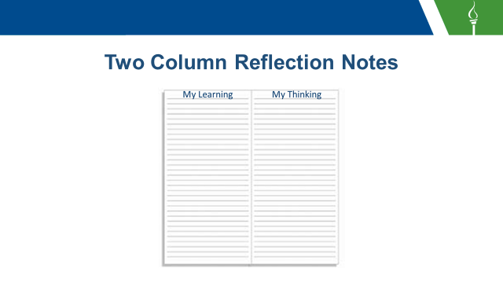

____________________________________________________________________________________________________________________________________________________________________________________________________________________________________________________________________________________________________________________________________________________________________________________________________________________________________________________________________________________________________________________________________________________________________________________________________________________________________________________________________________________________________________________________________________________________________________________________________________________________________________________________________________________________________________________________________________________________________________________________________________________________________________________________

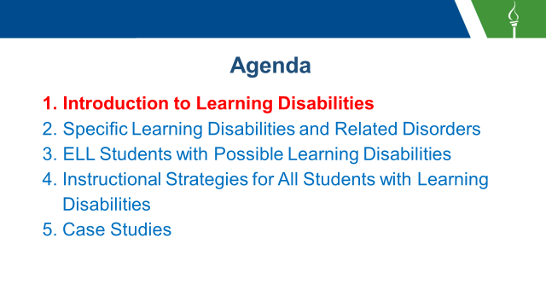

____________________________________________________________________________________________________________________________________________________________________________________________________________________________________________________________________________________________________________________________________________________________________________________________________________________________________________________________________________________________________________________________________________________________________________________________________________________________________________________________________________________________________________________________________________________________________________________________________________________________________________________________________________________________________________________________________________________________________________________________________________________________________________________________

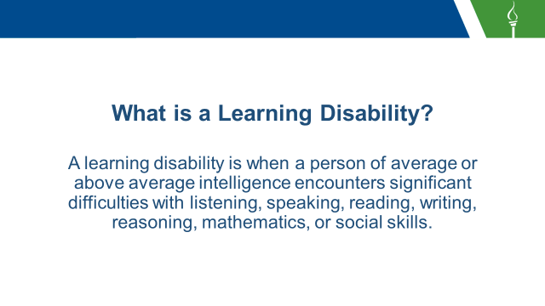

____________________________________________________________________________________________________________________________________________________________________________________________________________________________________________________________________________________________________________________________________________________________________________________________________________________________________________________________________________________________________________________________________________________________________________________________________________________________________________________________________________________________________________________________________________________________________________________________________________________________________________________________________________________________________________________________________________________________________________________________________________________________________________________________

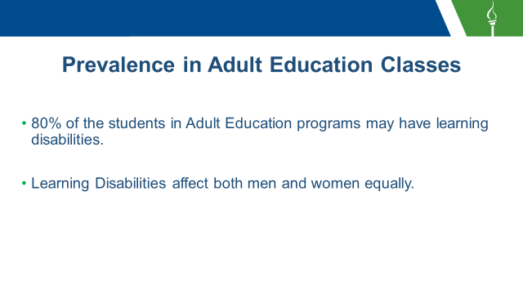

____________________________________________________________________________________________________________________________________________________________________________________________________________________________________________________________________________________________________________________________________________________________________________________________________________________________________________________________________________________________________________________________________________________________________________________________________________________________________________________________________________________________________________________________________________________________________________________________________________________________________________________________________________________________________________________________________________________________________________________________________________________________________________________________

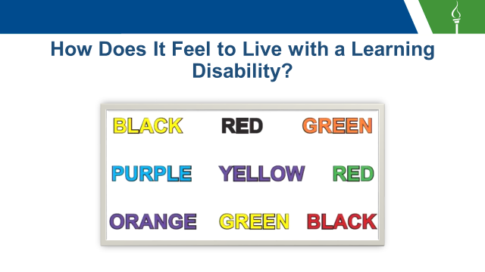

____________________________________________________________________________________________________________________________________________________________________________________________________________________________________________________________________________________________________________________________________________________________________________________________________________________________________________________________________________________________________________________________________________________________________________________________________________________________________________________________________________________________________________________________________________________________________________________________________________________________________________________________________________________________________________________________________________________________________________________________________________________________________________________________

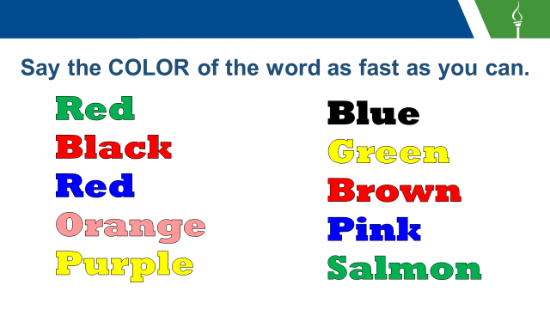

____________________________________________________________________________________________________________________________________________________________________________________________________________________________________________________________________________________________________________________________________________________________________________________________________________________________________________________________________________________________________________________________________________________________________________________________________________________________________________________________________________________________________________________________________________________________________________________________________________________________________________________________________________________________________________________________________________________________________________________________________________________________________________________________

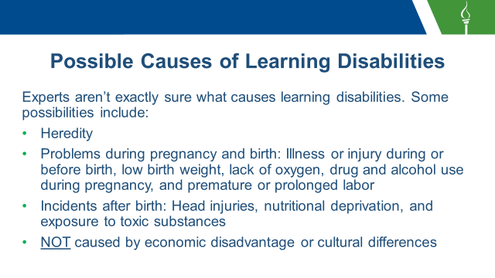

____________________________________________________________________________________________________________________________________________________________________________________________________________________________________________________________________________________________________________________________________________________________________________________________________________________________________________________________________________________________________________________________________________________________________________________________________________________________________________________________________________________________________________________________________________________________________________________________________________________________________________________________________________________________________________________________________________________________________________________________________________________________________________________________

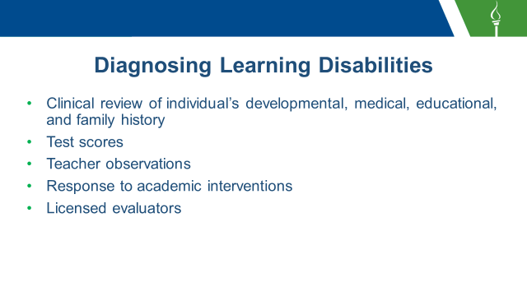

____________________________________________________________________________________________________________________________________________________________________________________________________________________________________________________________________________________________________________________________________________________________________________________________________________________________________________________________________________________________________________________________________________________________________________________________________________________________________________________________________________________________________________________________________________________________________________________________________________________________________________________________________________________________________________________________________________________________________________________________________________________________________________________________

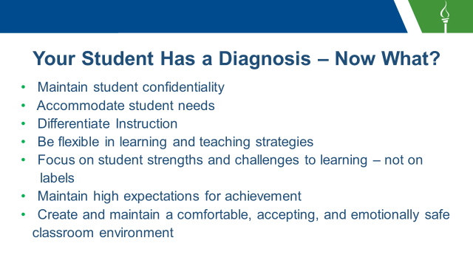

____________________________________________________________________________________________________________________________________________________________________________________________________________________________________________________________________________________________________________________________________________________________________________________________________________________________________________________________________________________________________________________________________________________________________________________________________________________________________________________________________________________________________________________________________________________________________________________________________________________________________________________________________________________________________________________________________________________________________________________________________________________________________________________________

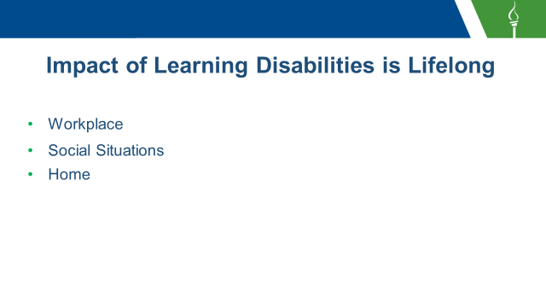

____________________________________________________________________________________________________________________________________________________________________________________________________________________________________________________________________________________________________________________________________________________________________________________________________________________________________________________________________________________________________________________________________________________________________________________________________________________________________________________________________________________________________________________________________________________________________________________________________________________________________________________________________________________________________________________________________________________________________________________________________________________________________________________________

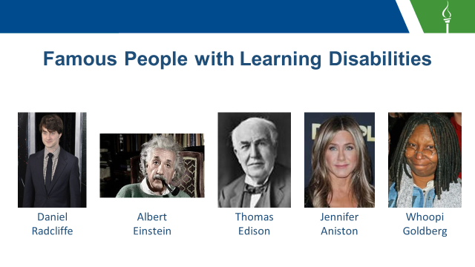

____________________________________________________________________________________________________________________________________________________________________________________________________________________________________________________________________________________________________________________________________________________________________________________________________________________________________________________________________________________________________________________________________________________________________________________________________________________________________________________________________________________________________________________________________________________________________________________________________________________________________________________________________________________________________________________________________________________________________________________________________________________________________________________________

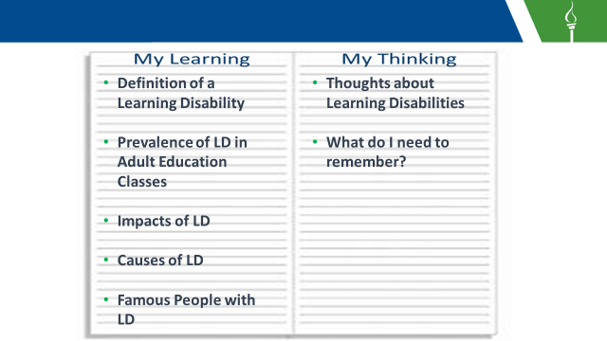

____________________________________________________________________________________________________________________________________________________________________________________________________________________________________________________________________________________________________________________________________________________________________________________________________________________________________________________________________________________________________________________________________________________________________________________________________________________________________________________________________________________________________________________________________________________________________________________________________________________________________________________________________________________________________________________________________________________________________________________________________________________________________________________________

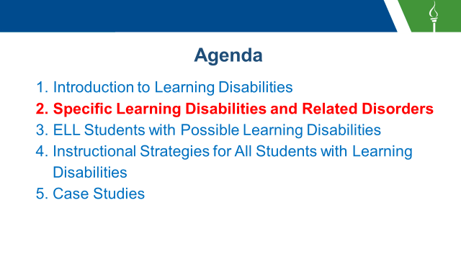

____________________________________________________________________________________________________________________________________________________________________________________________________________________________________________________________________________________________________________________________________________________________________________________________________________________________________________________________________________________________________________________________________________________________________________________________________________________________________________________________________________________________________________________________________________________________________________________________________________________________________________________________________________________________________________________________________________________________________________________________________________________________________________________________

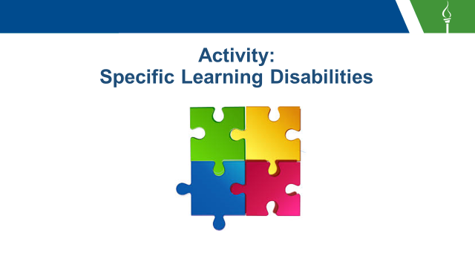

____________________________________________________________________________________________________________________________________________________________________________________________________________________________________________________________________________________________________________________________________________________________________________________________________________________________________________________________________________________________________________________________________________________________________________________________________________________________________________________________________________________________________________________________________________________________________________________________________________________________________________________________________________________________________________________________________________________________________________________________________________________________________________________________



____________________________________________________________________________________________________________________________________________________________________________________________________________________________________________________________________________________________________________________________________________________________________________________________________________________________________________________________________________________________________________________________________________________________________________________________________________________________________________________________________________________________________________________________________________________________________________________________________________________________________________________________________________________________________________________________________________________________________________________________________________________________________________________________

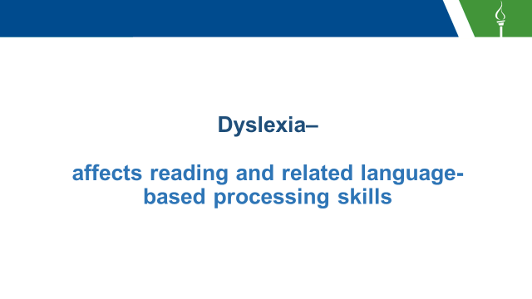

____________________________________________________________________________________________________________________________________________________________________________________________________________________________________________________________________________________________________________________________________________________________________________________________________________________________________________________________________________________________________________________________________________________________________________________________________________________________________________________________________________________________________________________________________________________________________________________________________________________________________________________________________________________________________________________________________________________________________________________________________________________________________________________________

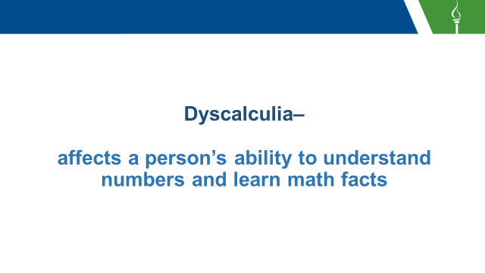

____________________________________________________________________________________________________________________________________________________________________________________________________________________________________________________________________________________________________________________________________________________________________________________________________________________________________________________________________________________________________________________________________________________________________________________________________________________________________________________________________________________________________________________________________________________________________________________________________________________________________________________________________________________________________________________________________________________________________________________________________________________________________________________________

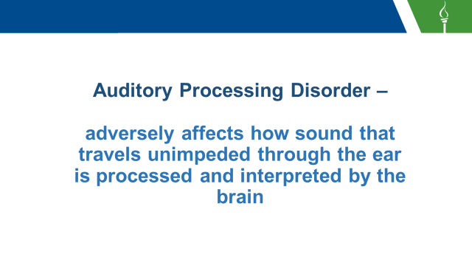

____________________________________________________________________________________________________________________________________________________________________________________________________________________________________________________________________________________________________________________________________________________________________________________________________________________________________________________________________________________________________________________________________________________________________________________________________________________________________________________________________________________________________________________________________________________________________________________________________________________________________________________________________________________________________________________________________________________________________________________________________________________________________________________________

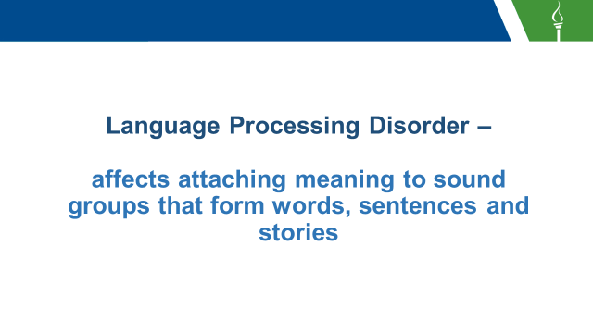

____________________________________________________________________________________________________________________________________________________________________________________________________________________________________________________________________________________________________________________________________________________________________________________________________________________________________________________________________________________________________________________________________________________________________________________________________________________________________________________________________________________________________________________________________________________________________________________________________________________________________________________________________________________________________________________________________________________________________________________________________________________________________________________________

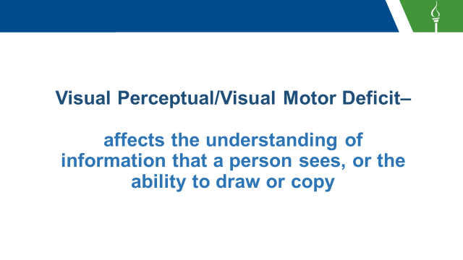

____________________________________________________________________________________________________________________________________________________________________________________________________________________________________________________________________________________________________________________________________________________________________________________________________________________________________________________________________________________________________________________________________________________________________________________________________________________________________________________________________________________________________________________________________________________________________________________________________________________________________________________________________________________________________________________________________________________________________________________________________________________________________________________________



____________________________________________________________________________________________________________________________________________________________________________________________________________________________________________________________________________________________________________________________________________________________________________________________________________________________________________________________________________________________________________________________________________________________________________________________________________________________________________________________________________________________________________________________________________________________________________________________________________________________________________________________________________________________________________________________________________________________________________________________________________________________________________________________

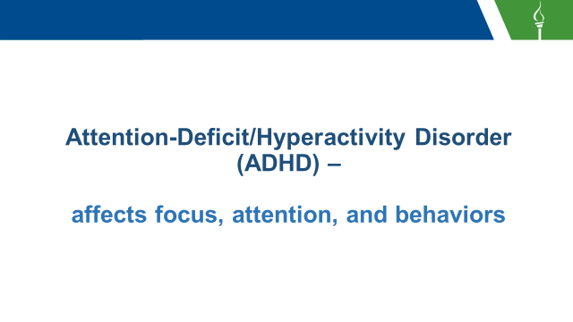

____________________________________________________________________________________________________________________________________________________________________________________________________________________________________________________________________________________________________________________________________________________________________________________________________________________________________________________________________________________________________________________________________________________________________________________________________________________________________________________________________________________________________________________________________________________________________________________________________________________________________________________________________________________________________________________________________________________________________________________________________________________________________________________________



____________________________________________________________________________________________________________________________________________________________________________________________________________________________________________________________________________________________________________________________________________________________________________________________________________________________________________________________________________________________________________________________________________________________________________________________________________________________________________________________________________________________________________________________________________________________________________________________________________________________________________________________________________________________________________________________________________________________________________________________________________________________________________________________

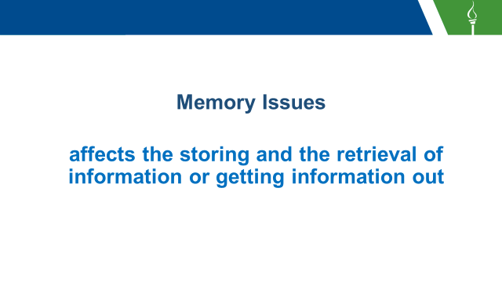

____________________________________________________________________________________________________________________________________________________________________________________________________________________________________________________________________________________________________________________________________________________________________________________________________________________________________________________________________________________________________________________________________________________________________________________________________________________________________________________________________________________________________________________________________________________________________________________________________________________________________________________________________________________________________________________________________________________________________________________________________________________________________________________________

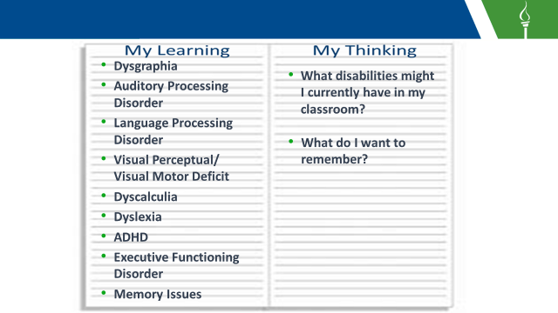

____________________________________________________________________________________________________________________________________________________________________________________________________________________________________________________________________________________________________________________________________________________________________________________________________________________________________________________________________________________________________________________________________________________________________________________________________________________________________________________________________________________________________________________________________________________________________________________________________________________________________________________________________________________________________________________________________________________________________________________________________________________________________________________________

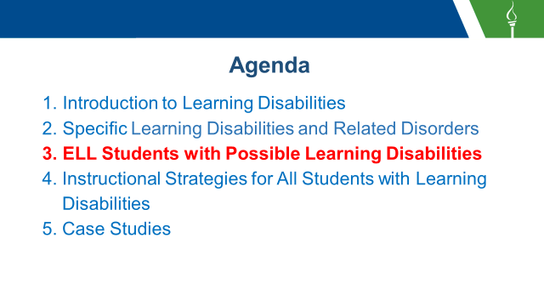

____________________________________________________________________________________________________________________________________________________________________________________________________________________________________________________________________________________________________________________________________________________________________________________________________________________________________________________________________________________________________________________________________________________________________________________________________________________________________________________________________________________________________________________________________________________________________________________________________________________________________________________________________________________________________________________________________________________________________________________________________________________________________________________________

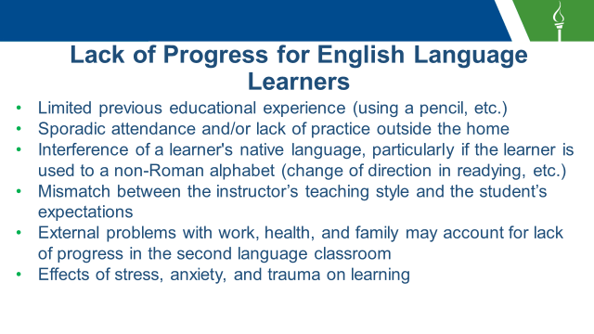

____________________________________________________________________________________________________________________________________________________________________________________________________________________________________________________________________________________________________________________________________________________________________________________________________________________________________________________________________________________________________________________________________________________________________________________________________________________________________________________________________________________________________________________________________________________________________________________________________________________________________________________________________________________________________________________________________________________________________________________________________________________________________________________________

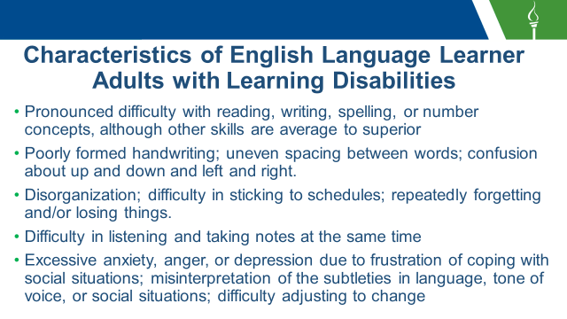

____________________________________________________________________________________________________________________________________________________________________________________________________________________________________________________________________________________________________________________________________________________________________________________________________________________________________________________________________________________________________________________________________________________________________________________________________________________________________________________________________________________________________________________________________________________________________________________________________________________________________________________________________________________________________________________________________________________________________________________________________________________________________________________________

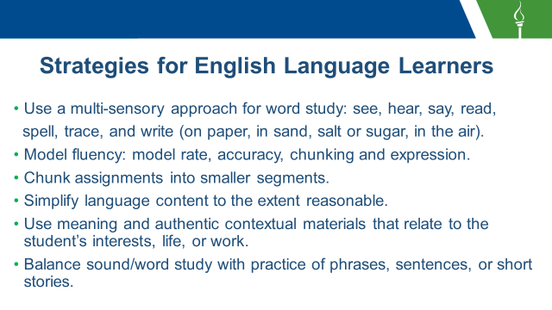

____________________________________________________________________________________________________________________________________________________________________________________________________________________________________________________________________________________________________________________________________________________________________________________________________________________________________________________________________________________________________________________________________________________________________________________________________________________________________________________________________________________________________________________________________________________________________________________________________________________________________________________________________________________________________________________________________________________________________________________________________________________________________________________________

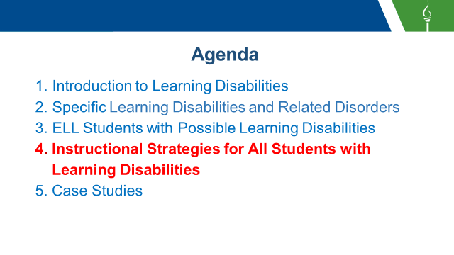

____________________________________________________________________________________________________________________________________________________________________________________________________________________________________________________________________________________________________________________________________________________________________________________________________________________________________________________________________________________________________________________________________________________________________________________________________________________________________________________________________________________________________________________________________________________________________________________________________________________________________________________________________________________________________________________________________________________________________________________________________________________________________________________________



____________________________________________________________________________________________________________________________________________________________________________________________________________________________________________________________________________________________________________________________________________________________________________________________________________________________________________________________________________________________________________________________________________________________________________________________________________________________________________________________________________________________________________________________________________________________________________________________________________________________________________________________________________________________________________________________________________________________________________________________________________________________________________________________

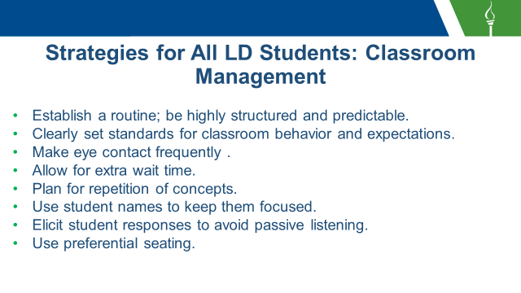

____________________________________________________________________________________________________________________________________________________________________________________________________________________________________________________________________________________________________________________________________________________________________________________________________________________________________________________________________________________________________________________________________________________________________________________________________________________________________________________________________________________________________________________________________________________________________________________________________________________________________________________________________________________________________________________________________________________________________________________________________________________________________________________________

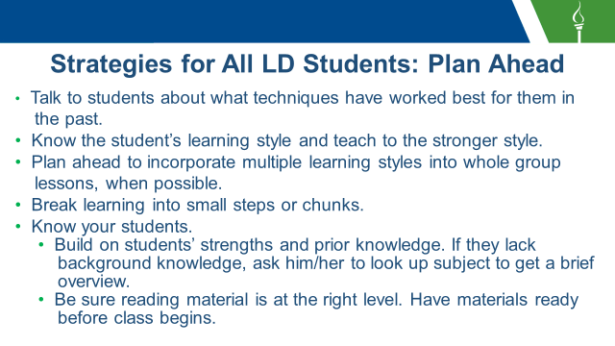

____________________________________________________________________________________________________________________________________________________________________________________________________________________________________________________________________________________________________________________________________________________________________________________________________________________________________________________________________________________________________________________________________________________________________________________________________________________________________________________________________________________________________________________________________________________________________________________________________________________________________________________________________________________________________________________________________________________________________________________________________________________________________________________________

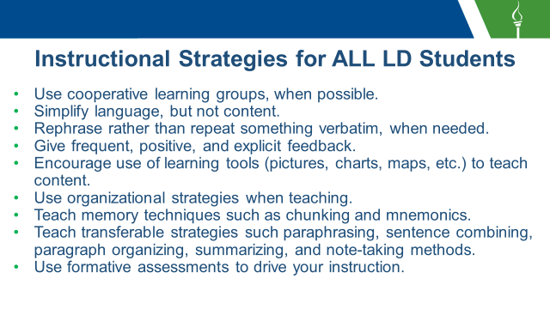

____________________________________________________________________________________________________________________________________________________________________________________________________________________________________________________________________________________________________________________________________________________________________________________________________________________________________________________________________________________________________________________________________________________________________________________________________________________________________________________________________________________________________________________________________________________________________________________________________________________________________________________________________________________________________________________________________________________________________________________________________________________________________________________________

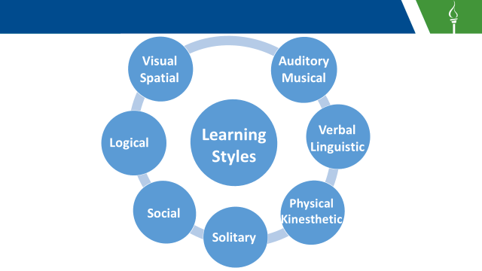

____________________________________________________________________________________________________________________________________________________________________________________________________________________________________________________________________________________________________________________________________________________________________________________________________________________________________________________________________________________________________________________________________________________________________________________________________________________________________________________________________________________________________________________________________________________________________________________________________________________________________________________________________________________________________________________________________________________________________________________________________________________________________________________________

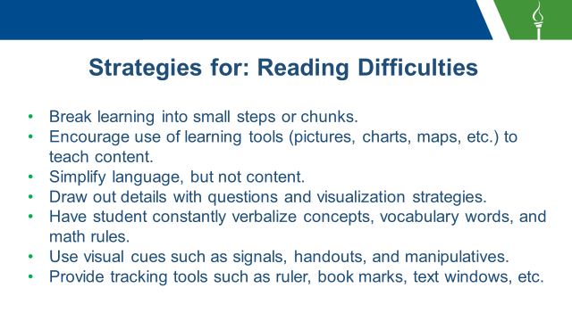

____________________________________________________________________________________________________________________________________________________________________________________________________________________________________________________________________________________________________________________________________________________________________________________________________________________________________________________________________________________________________________________________________________________________________________________________________________________________________________________________________________________________________________________________________________________________________________________________________________________________________________________________________________________________________________________________________________________________________________________________________________________________________________________________

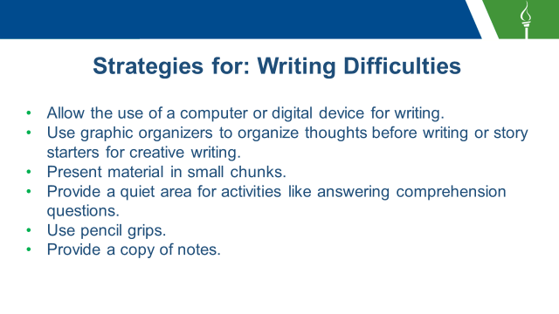

____________________________________________________________________________________________________________________________________________________________________________________________________________________________________________________________________________________________________________________________________________________________________________________________________________________________________________________________________________________________________________________________________________________________________________________________________________________________________________________________________________________________________________________________________________________________________________________________________________________________________________________________________________________________________________________________________________________________________________________________________________________________________________________________

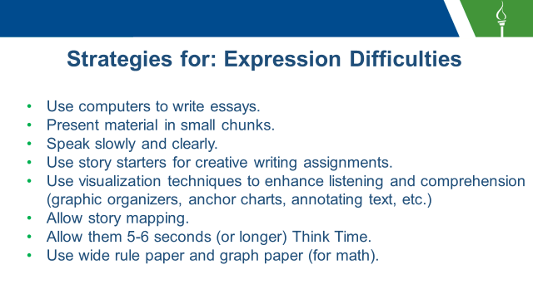

____________________________________________________________________________________________________________________________________________________________________________________________________________________________________________________________________________________________________________________________________________________________________________________________________________________________________________________________________________________________________________________________________________________________________________________________________________________________________________________________________________________________________________________________________________________________________________________________________________________________________________________________________________________________________________________________________________________________________________________________________________________________________________________________

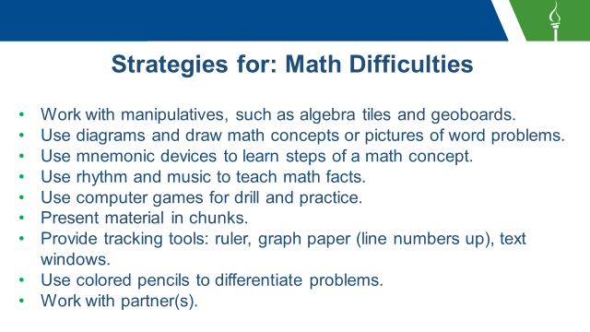

____________________________________________________________________________________________________________________________________________________________________________________________________________________________________________________________________________________________________________________________________________________________________________________________________________________________________________________________________________________________________________________________________________________________________________________________________________________________________________________________________________________________________________________________________________________________________________________________________________________________________________________________________________________________________________________________________________________________________________________________________________________________________________________________

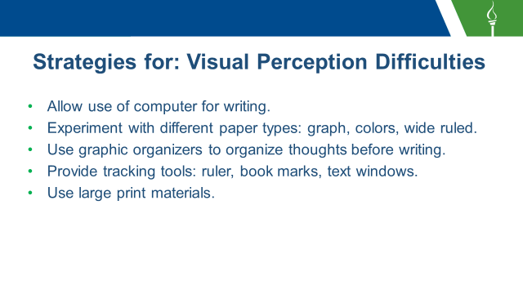

____________________________________________________________________________________________________________________________________________________________________________________________________________________________________________________________________________________________________________________________________________________________________________________________________________________________________________________________________________________________________________________________________________________________________________________________________________________________________________________________________________________________________________________________________________________________________________________________________________________________________________________________________________________________________________________________________________________________________________________________________________________________________________________________

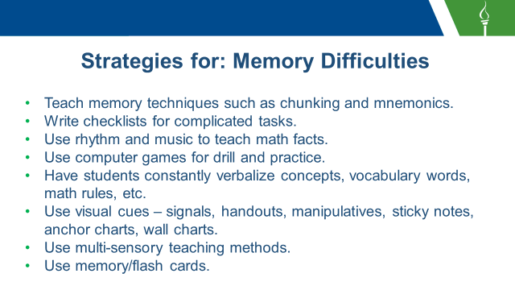

____________________________________________________________________________________________________________________________________________________________________________________________________________________________________________________________________________________________________________________________________________________________________________________________________________________________________________________________________________________________________________________________________________________________________________________________________________________________________________________________________________________________________________________________________________________________________________________________________________________________________________________________________________________________________________________________________________________________________________________________________________________________________________________________

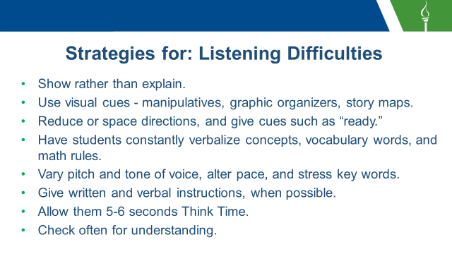

____________________________________________________________________________________________________________________________________________________________________________________________________________________________________________________________________________________________________________________________________________________________________________________________________________________________________________________________________________________________________________________________________________________________________________________________________________________________________________________________________________________________________________________________________________________________________________________________________________________________________________________________________________________________________________________________________________________________________________________________________________________________________________________________

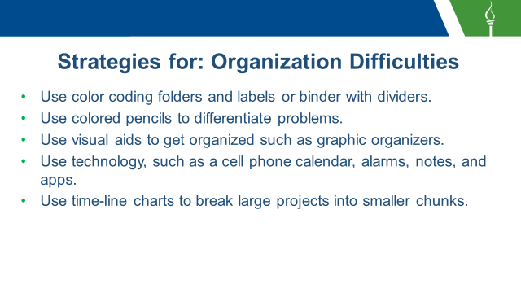

____________________________________________________________________________________________________________________________________________________________________________________________________________________________________________________________________________________________________________________________________________________________________________________________________________________________________________________________________________________________________________________________________________________________________________________________________________________________________________________________________________________________________________________________________________________________________________________________________________________________________________________________________________________________________________________________________________________________________________________________________________________________________________________________

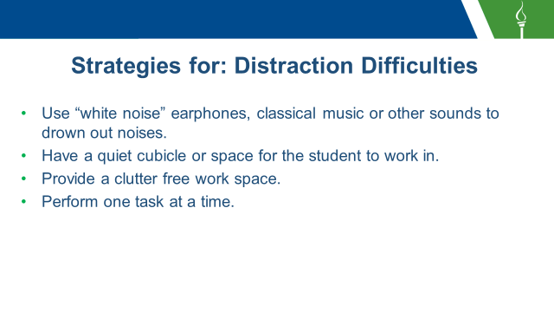

____________________________________________________________________________________________________________________________________________________________________________________________________________________________________________________________________________________________________________________________________________________________________________________________________________________________________________________________________________________________________________________________________________________________________________________________________________________________________________________________________________________________________________________________________________________________________________________________________________________________________________________________________________________________________________________________________________________________________________________________________________________________________________________________

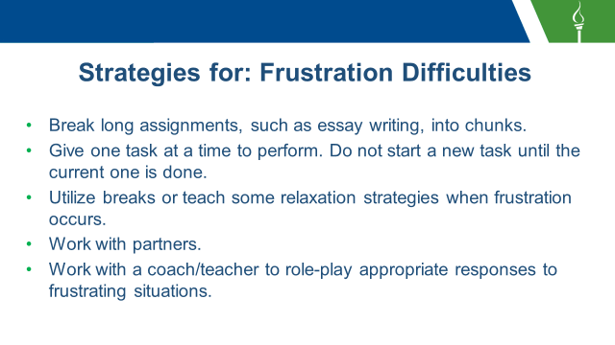

____________________________________________________________________________________________________________________________________________________________________________________________________________________________________________________________________________________________________________________________________________________________________________________________________________________________________________________________________________________________________________________________________________________________________________________________________________________________________________________________________________________________________________________________________________________________________________________________________________________________________________________________________________________________________________________________________________________________________________________________________________________________________________________________

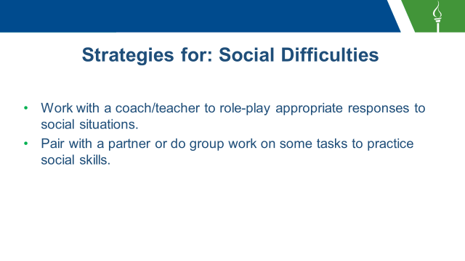

____________________________________________________________________________________________________________________________________________________________________________________________________________________________________________________________________________________________________________________________________________________________________________________________________________________________________________________________________________________________________________________________________________________________________________________________________________________________________________________________________________________________________________________________________________________________________________________________________________________________________________________________________________________________________________________________________________________________________________________________________________________________________________________________

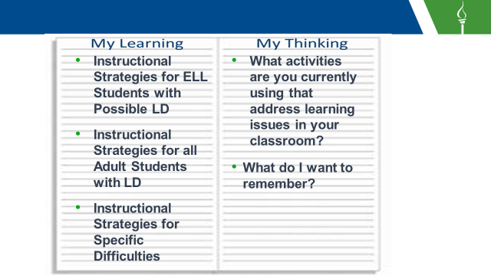

____________________________________________________________________________________________________________________________________________________________________________________________________________________________________________________________________________________________________________________________________________________________________________________________________________________________________________________________________________________________________________________________________________________________________________________________________________________________________________________________________________________________________________________________________________________________________________________________________________________________________________________________________________________________________________________________________________________________________________________________________________________________________________________________

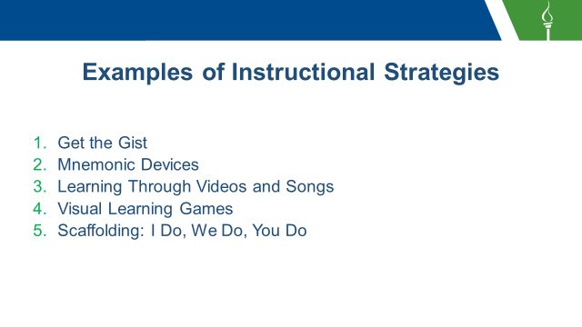

____________________________________________________________________________________________________________________________________________________________________________________________________________________________________________________________________________________________________________________________________________________________________________________________________________________________________________________________________________________________________________________________________________________________________________________________________________________________________________________________________________________________________________________________________________________________________________________________________________________________________________________________________________________________________________________________________________________________________________________________________________________________________________________________



____________________________________________________________________________________________________________________________________________________________________________________________________________________________________________________________________________________________________________________________________________________________________________________________________________________________________________________________________________________________________________________________________________________________________________________________________________________________________________________________________________________________________________________________________________________________________________________________________________________________________________________________________________________________________________________________________________________________________________________________________________________________________________________________

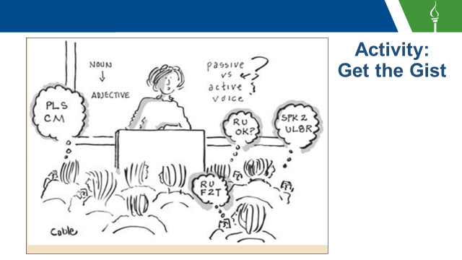

____________________________________________________________________________________________________________________________________________________________________________________________________________________________________________________________________________________________________________________________________________________________________________________________________________________________________________________________________________________________________________________________________________________________________________________________________________________________________________________________________________________________________________________________________________________________________________________________________________________________________________________________________________________________________________________________________________________________________________________________________________________________________________________________

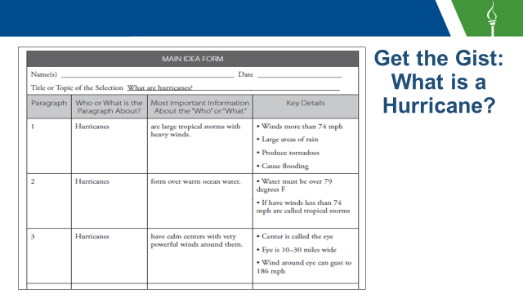

____________________________________________________________________________________________________________________________________________________________________________________________________________________________________________________________________________________________________________________________________________________________________________________________________________________________________________________________________________________________________________________________________________________________________________________________________________________________________________________________________________________________________________________________________________________________________________________________________________________________________________________________________________________________________________________________________________________________________________________________________________________________________________________________

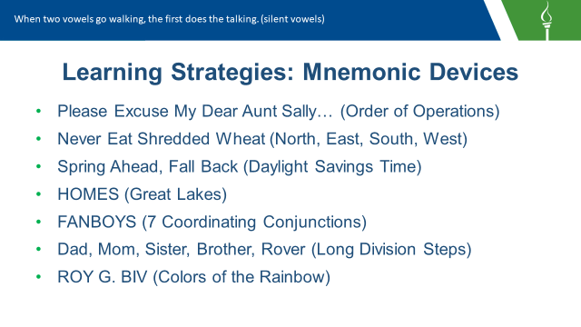

____________________________________________________________________________________________________________________________________________________________________________________________________________________________________________________________________________________________________________________________________________________________________________________________________________________________________________________________________________________________________________________________________________________________________________________________________________________________________________________________________________________________________________________________________________________________________________________________________________________________________________________________________________________________________________________________________________________________________________________________________________________________________________________________



____________________________________________________________________________________________________________________________________________________________________________________________________________________________________________________________________________________________________________________________________________________________________________________________________________________________________________________________________________________________________________________________________________________________________________________________________________________________________________________________________________________________________________________________________________________________________________________________________________________________________________________________________________________________________________________________________________________________________________________________________________________________________________________________

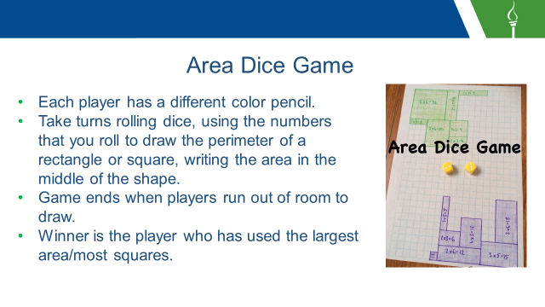

____________________________________________________________________________________________________________________________________________________________________________________________________________________________________________________________________________________________________________________________________________________________________________________________________________________________________________________________________________________________________________________________________________________________________________________________________________________________________________________________________________________________________________________________________________________________________________________________________________________________________________________________________________________________________________________________________________________________________________________________________________________________________________________________

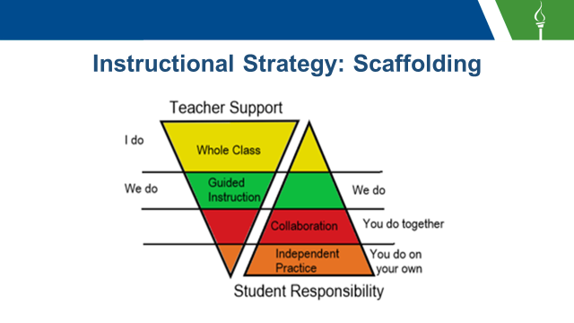

____________________________________________________________________________________________________________________________________________________________________________________________________________________________________________________________________________________________________________________________________________________________________________________________________________________________________________________________________________________________________________________________________________________________________________________________________________________________________________________________________________________________________________________________________________________________________________________________________________________________________________________________________________________________________________________________________________________________________________________________________________________________________________________________

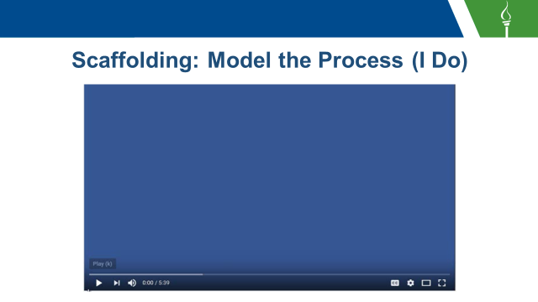

____________________________________________________________________________________________________________________________________________________________________________________________________________________________________________________________________________________________________________________________________________________________________________________________________________________________________________________________________________________________________________________________________________________________________________________________________________________________________________________________________________________________________________________________________________________________________________________________________________________________________________________________________________________________________________________________________________________________________________________________________________________________________________________________

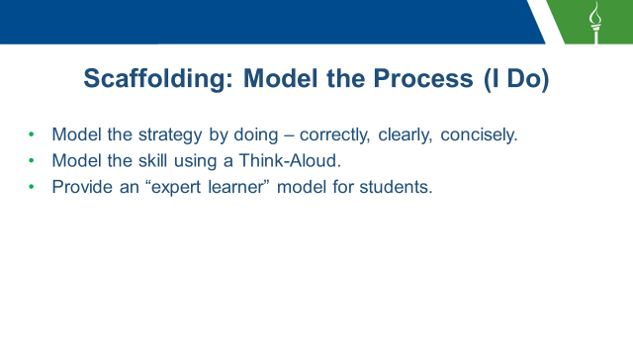

____________________________________________________________________________________________________________________________________________________________________________________________________________________________________________________________________________________________________________________________________________________________________________________________________________________________________________________________________________________________________________________________________________________________________________________________________________________________________________________________________________________________________________________________________________________________________________________________________________________________________________________________________________________________________________________________________________________________________________________________________________________________________________________________

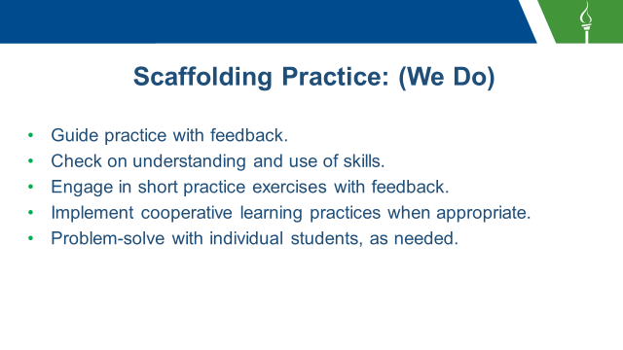

____________________________________________________________________________________________________________________________________________________________________________________________________________________________________________________________________________________________________________________________________________________________________________________________________________________________________________________________________________________________________________________________________________________________________________________________________________________________________________________________________________________________________________________________________________________________________________________________________________________________________________________________________________________________________________________________________________________________________________________________________________________________________________________________

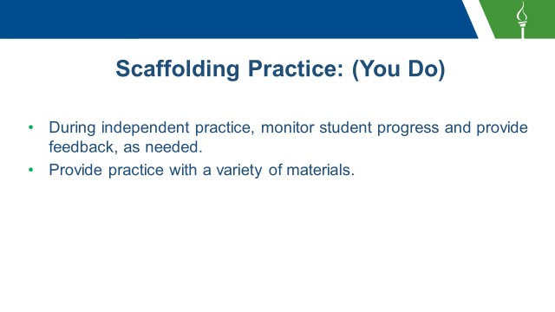

____________________________________________________________________________________________________________________________________________________________________________________________________________________________________________________________________________________________________________________________________________________________________________________________________________________________________________________________________________________________________________________________________________________________________________________________________________________________________________________________________________________________________________________________________________________________________________________________________________________________________________________________________________________________________________________________________________________________________________________________________________________________________________________________

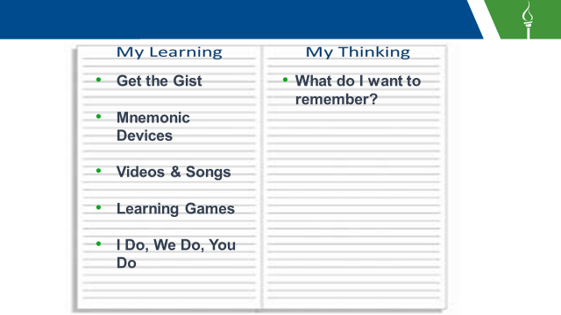

____________________________________________________________________________________________________________________________________________________________________________________________________________________________________________________________________________________________________________________________________________________________________________________________________________________________________________________________________________________________________________________________________________________________________________________________________________________________________________________________________________________________________________________________________________________________________________________________________________________________________________________________________________________________________________________________________________________________________________________________________________________________________________________________

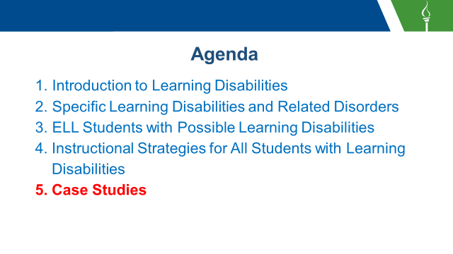

____________________________________________________________________________________________________________________________________________________________________________________________________________________________________________________________________________________________________________________________________________________________________________________________________________________________________________________________________________________________________________________________________________________________________________________________________________________________________________________________________________________________________________________________________________________________________________________________________________________________________________________________________________________________________________________________________________________________________________________________________________________________________________________________



____________________________________________________________________________________________________________________________________________________________________________________________________________________________________________________________________________________________________________________________________________________________________________________________________________________________________________________________________________________________________________________________________________________________________________________________________________________________________________________________________________________________________________________________________________________________________________________________________________________________________________________________________________________________________________________________________________________________________________________________________________________________________________________________



____________________________________________________________________________________________________________________________________________________________________________________________________________________________________________________________________________________________________________________________________________________________________________________________________________________________________________________________________________________________________________________________________________________________________________________________________________________________________________________________________________________________________________________________________________________________________________________________________________________________________________________________________________________________________________________________________________________________________________________________________________________________________________________________

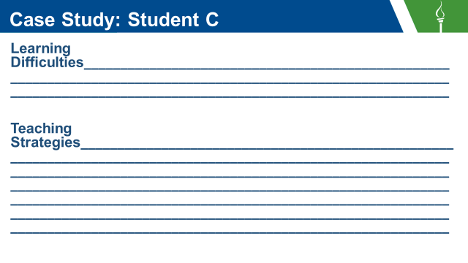

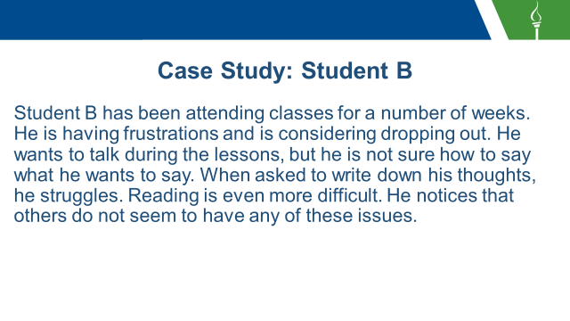

____________________________________________________________________________________________________________________________________________________________________________________________________________________________________________________________________________________________________________________________________________________________________________________________________________________________________________________________________________________________________________________________________________________________________________________________________________________________________________________________________________________________________________________________________________________________________________________________________________________________________________________________________________________________________________________________________________________________________________________________________________________________________________________________

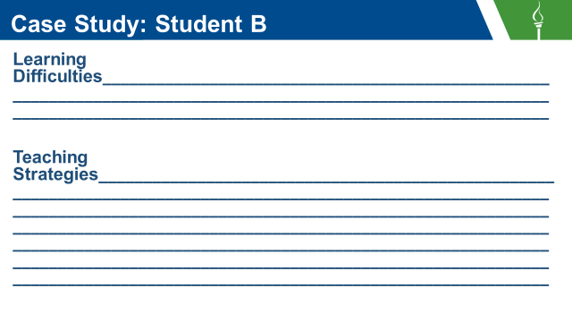

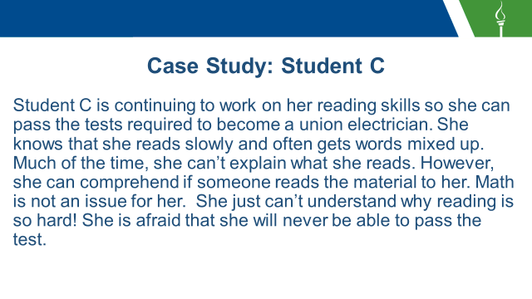

____________________________________________________________________________________________________________________________________________________________________________________________________________________________________________________________________________________________________________________________________________________________________________________________________________________________________________________________________________________________________________________________________________________________________________________________________________________________________________________________________________________________________________________________________________________________________________________________________________________________________________________________________________________________________________________________________________________________________________________________________________________________________________________________



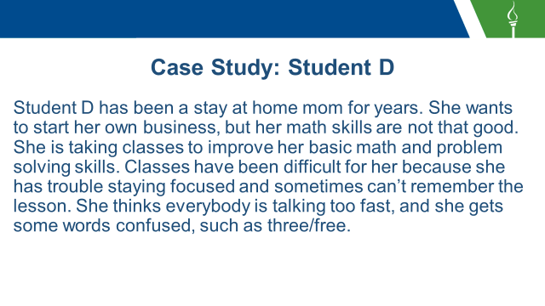

____________________________________________________________________________________________________________________________________________________________________________________________________________________________________________________________________________________________________________________________________________________________________________________________________________________________________________________________________________________________________________________________________________________________________________________________________________________________________________________________________________________________________________________________________________________________________________________________________________________________________________________________________________________________________________________________________________________________________________________________________________________________________________________________

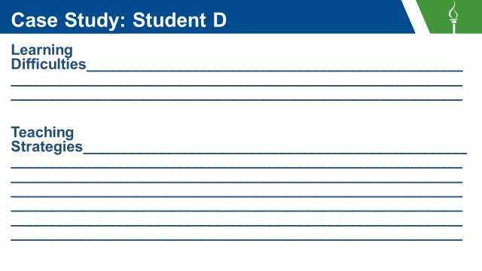

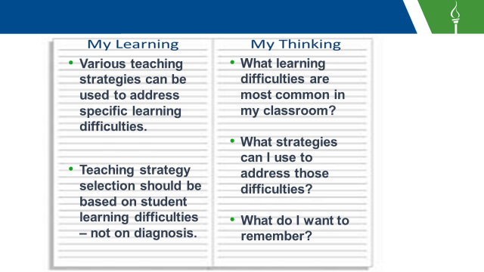

____________________________________________________________________________________________________________________________________________________________________________________________________________________________________________________________________________________________________________________________________________________________________________________________________________________________________________________________________________________________________________________________________________________________________________________________________________________________________________________________________________________________________________________________________________________________________________________________________________________________________________________________________________________________________________________________________________________________________________________________________________________________________________________________



____________________________________________________________________________________________________________________________________________________________________________________________________________________________________________________________________________________________________________________________________________________________________________________________________________________________________________________________________________________________________________________________________________________________________________________________________________________________________________________________________________________________________________________________________________________________________________________________________________________________________________________________________________________________________________________________________________________________________________________________________________________________________________________________

Appendix

**Get the GIST**

Name ______________________________________________________

Title ______________________________________________________

Source _____________________________________________________

1. Read the article or section of text.
2. Fill in the 5 Ws and H.

Who:

What:

When:

Where:

Why:

How:

3. Write a 20-word GIST summary.

__________ __________ __________ __________ __________

__________ __________ __________ __________ __________

__________ __________ __________ __________ __________

__________ __________ __________ __________ __________

|  |  |  |  |
| --- | --- | --- | --- |
| MAIN IDEA FORM | | | |
| Name(s) Date  Title or Topic of the Selection | | | |
| Paragraph | Who or What is the Paragraph About? | Most Important Information About the “Who” or “What” | Key Details |
|  |  |  |  |
|  |  |  |  |
|  |  |  |  |
|  |  |  |  |
|  |  |  |  |

**Mnemonics**

Order of Operations: Please (parentheses) Excuse (exponents) My (multiply) Dear (division) Aunt (addition) Sally (subtraction)

Cardinal Directions: Never (North) Eat (East) Shredded (South) Wheat (West)

Great Lakes: H (Huron) O (Ontario) M (Michigan) E (Erie) S (Superior)

7 Coordinating Conjunctions: For And Nor But Or Yet So

Long Division Steps: Dad (Divide) Mom (Multiply) Sister (Subtract) Brother (Bring Down) Rover (Remainder)

Colors of the Rainbow: R (red) O (Orange) Y (Yellow) G (Green) B(Blue) I (Indigo) V (violet)

Planets in Order: My (mercury) Very (venus) Excellent (earth) Mother (mars) Just (Jupiter) Served (Saturn) Us (Uranus) Nachos (Neptune).

Order of Taxonomy: King (kingdom) Phillip (phylum) Came (class) Over (order) For (family) Great (genus) Spaghetti (species)

Rhymes:

Silent Vowels: When two vowels go walking, the first does the talking.

Number of Days in Months: Thirty days hath September, April, June, and November

February has 28 alone,

All the rest have 31

Except in Leap Year,

That’s the time

When February’s days are 29.

Writing B and D: B is for bright, so put the circle on the right.

Silent Vowels: When two vowels go walking, the first does the talking.

Spelling: I before e, except after c

Arithmetic: A Rat In The House Might Eat The Ice Cream

Geography: George Edward’s Old Grandma Rode a Pig Home Yesterday

Christopher Columbus: Columbus sailed the ocean blue in fourteen hundred ninety-two

Constitution: ABCD

A- All RAPPS Freedom of religion, assembly, petition, press, and speech

B- Bear Arms The Right to Bear Arms

C- Can’t Intrude Quartering of Troops

D- Don’t Search and Seizure, Search Warrants

This song can be sung to both the tune of “Pop Goes the Weasel” and/or “Row, Row, Row, Your Boat”.

The opposite of b,

Plus or minus the square root,

Of b squared minus 4 a c,

All over 2a.

There are also some really cool songs made up by WSHS (high school) which can be found at these links:

<https://www.youtube.com/watch?v=1qHTmxlaZWQ> – All I Do Is Solve

<https://www.youtube.com/watch?v=OsEd7X5XuCU> – Solve Me Maybe

<https://www.youtube.com/watch?v=2BHzXItkByU> – Graph!

<https://www.youtube.com/watch?v=QIZTruxt2rQ> – Super Base

<https://www.youtube.com/watch?v=OFSrINhfNsQ> – Teach Me How to Factor

<https://www.youtube.com/watch?v=jGJrH49Z2ZA> – Do the Quad Solve

**Dysgraphia**affects a person’s handwriting ability and fine motor skills.

# Signs and Symptoms

* May have illegible printing and cursive writing
* Shows inconsistencies: mixtures of print and cursive, upper and lower case, or irregular shapes, shapes or slant of letters
* Has unfinished words or letters, omitted words
* Inconsistent spacing between words and letters
* Exhibits strange wrist, body or paper position when writing; may complain of sore hand
* Copying or writing is slow or labored
* Has great difficulty thinking and writing at the same time (taking notes, creative writing)

# Strategies

* Use wide rule paper and graph paper
* Use pencil grips
* Use computer or digital device to write
* Use graphic organizers to organize thoughts before writing
* Provide notes, outlines, or handouts to reduce the amount of writing required

**Auditory Processing Disorder**adversely affects how sound that travels unimpeded through the ear is processed and interpreted by the brain.

# Signs and Symptoms

* Has difficulty processing and remembering language-related tasks but may have no trouble interpreting or recalling non-verbal environmental sounds, music, etc.
* May process thoughts slowly and have difficulty explaining them.
* Misspells and mispronounces similar-sounding words or omits syllables; confuses similar-sounding words (celery/salary; built/belt; three/free)
* Interprets words too literally and may be confused by figurative language & puns
* Distracted by background sounds & noises
* Has difficulty staying focused on background sounds & noises
* May misinterpret or have difficulty remembering oral directions
* Has difficulty comprehending rapid speech or complex sentence structure
* Ignores people, especially if engrossed
* Says “What?” a lot, even when has heard much of what was said

# Strategies

* Have student constantly verbalize concepts, vocabulary words, math rules, etc.
* Vary pitch and tone of voice, alter pace, stress key words
* Allow student 5-6 seconds Think Time
* Ask questions to see if student understands
* Direct instruction of vocabulary, word roots, synonyms/antonyms
* Reword confusing oral and/or written directions
* Reduce or space directions, give cues such as “ready?”
* Show rather than explain
* Use visual cues – signals, handouts, manipulatives

**Language Processing Disorder**affects attaching meaning to sound groups that form words, sentences and stories.

# Signs and Symptoms

* Has difficulty gaining meaning from spoken language
* Exhibits poor reading comprehension
* Has difficulty expressing thoughts in verbal form
* Feels that words are “right on the tip of their tongue”
* Has difficulty getting jokes
* May be depressed or have feelings of sadness
* Can describe an object and draw it, but cannot think of the word for it
* Often frustrated by having a lot to say and no way to say it
* Has difficulty labeling objects or recognizing labels

# Strategies

* Speak slowly and clearly and use simple sentences.
* Use graphic organizers for note taking.
* Use story starters for creative writing assignments.
* Write main concepts on board.
* Provide peer tutor.
* Draw out details with questions and visualization strategies.
* Use visualization techniques to enhance listening and comprehension.
* Allow story mapping.

**Visual Perceptual/Visual Motor Deficit**affects the understanding of information that a person sees, or the ability to draw or copy.

# Signs and Symptoms

* May have reversals: b for d, p for q or inversions: u for n, w for m
* Has difficulty negotiating around campus
* Complains eyes hurt and itch, rubs eyes, complains print blurs while reading
* Turns head when reading across page or holds paper at odd angles
* Closes one eye while working, may yawn while reading
* Cannot copy accurately
* Loses place frequently
* Holds pencil too tightly; often breaks pencil point
* Misaligns letters; may have messy papers, which can include letters colliding, irregular spacing, letters not on line

# Strategies

* Provide tracking tools: ruler, book marks, text windows.
* Use large print books.
* Experiment with different paper types: pastels, graph, embossed raised line paper.
* Provide alternative for written assignments.
* Use pencil grips.
* Allow use of computer or digital device for writing.
* Reduce copying tasks.
* Order or check out audio books.

**Dyscalculia**affects a person’s ability to understand numbers and learn math facts.

# Signs and Symptoms

* Has difficulty understanding fractions
* Is challenged making change and handling money
* Shows difficulty understanding concepts of place value, number lines, positive and negative numbers, carrying and borrowing
* Has difficulty understanding and doing word problems
* Has difficulty sequencing information or events
* Exhibits difficulty using steps involved in math operations
* Displays difficulty recognizing patterns when adding, subtracting, multiplying, or dividing
* Has difficulty putting language to math processes
* Has difficulty understanding concepts related to time such as days, weeks, months, seasons, quarters, etc.
* Exhibits difficulty organizing problems on the page, keeping numbers lined up, following through on long division problems

# Strategies

* Allow use of fingers and scratch paper
* Work with manipulatives, such as algebra tiles
* Use diagrams and draw math concepts
* Work with a partner
* Use graph paper to line numbers up when calculating
* Use colored pencils to differentiate problems
* Draw pictures of word problems
* Use mnemonic devices to learn steps of a math concept
* Use rhythm and music to teach math facts
* Use computer games for drill and practice

**Dyslexia**affects reading and related language-based processing skills.

# Signs and Symptoms

* Reads slowly and painfully
* Has decoding errors, especially with the order of letters
* Shows wide disparity between listening comprehension and reading comprehension
* May have difficulty with spelling and handwriting
* Exhibits difficulty recalling known words
* Has difficulty with written language
* May experience difficulty with math computations
* Substitutes one small sight word for another: a, I, he, the, there, was

# Strategies

* Present material in small chunks
* Use volunteers or tutors to scribe when possible
* Provide a copy of lecture notes
* Use computers to write essays
* Use multi-sensory teaching methods
* Teach students to use logic rather than rote memory
* Use books with large print or audio books
* Provide a quiet area for activities like reading, answering comprehension questions

## Related Disorder

**Attention-Deficit/Hyperactivity Disorder (ADHD)**affects focus, attention and behavior and can make learning challenging.

# Signs and Symptoms

* May have difficulties with distractibility- paying attention.
* May have difficulties with working memory.
* May have difficulties at work and experience relationship issues.
* May have difficulty with impulsivity-considering long-term consequences of their actions.
* May have issues with procrastination, completing tasks, and meeting deadlines.
* May have difficulties with organization.
* May struggle with depression, mood or conduct disorders and substance abuse.
* May have chronic feelings of frustration, guilt, or blame.

# Strategies

* Distractibility
  + As much as possible, use a structured schedule.
  + Have a quiet cubicle or office or quiet cubicle for the student to work in.
  + Use “white noise” earphones, classical music or other sounds to drown out noises.
  + Have student jot down new ideas in a notebook to avoid interruption of the current task.
  + Perform one task at a time. Do not start a new task until the current one is done.
* Poor Memory
  + Use tape recording devices or take copious notes.
  + Write checklists for complicated tasks.
  + Use a cell phone calendar.
  + Use a day planner.
  + Write notes on sticky pads and put them in a highly visible place.
* Impulsivity
  + Learn to use self-talk to monitor impulsive actions.
  + Work with a coach to role-play appropriate responses to frustrating situations.
  + Ask for regular, constructive feedback as a way of becoming more aware of how impulsivity might manifest in you.
  + Practice relaxation and meditation techniques.
  + Anticipate the problems that regularly trigger impulsive reactions and develop routines for coping with these situations.
* Time management difficulties
  + Use time-line charts to break large projects into smaller pieces, with step-by-step due dates.
  + Use watch devices with alarms, buzzers, planners or computer planning software.
  + Avoid over-scheduling the day by overestimating how long each task will take.
* Procrastination
  + Pair with a co-worker who manages time well.
  + Set a deadline for tasks.
  + Break the task into small chunks, rewarding yourself along the way.
* Organization: Paperwork/details
  + Make it a rule to handle each piece of paper only once.
  + Keep only papers that are currently in use; purge the rest.
  + Use color coding folders and labels.
  + Ask an administrative assistant to handle detailed paperwork.

## Related Disorder

**Executive Functioning Disorder**affects planning, organization, strategizing, attention to details, and managing time and space.

**Signs and Symptoms**

* Has difficulty managing time, planning and organizing, keeping to a schedule, remembering instructions, completing tasks and meeting deadlines.
* Has difficulty multitasking.
* May not be able to avoid doing or saying the wrong thing in social situations. May overreact.
* May have difficulty switching focus and adjusting to change.

**Strategies**

* Use of classroom binder with dividers to help student organize papers.
* Use sticky notes, lists, mnemonic devices, and journals.
* Use of technology, such as cell phone calendar, alarms, notes, and apps.
* Use visual aids to get organized.
* Give written and verbal instructions, when possible.
* Break long assignments, such as essay writing into chunks.
* Provide a clutter free work space and classroom.

