User Instructions for the Apple iPad and Opening the Visible Body App
Powering on and logging into the iPad
- Press and hold the sleep/wake button until the Apple logo appears on the screen.
- 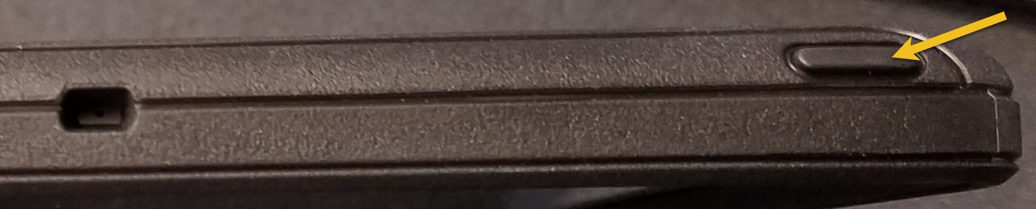
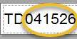
- Locate the white sticker on the top right side of the iPad screen.

- When the iPad asks for the passcode, enter the 6 digit number from the white sticker. (If the iPad doesn’t ask for the passcode, press the Home button until it does)

Logging into OTC-wifi
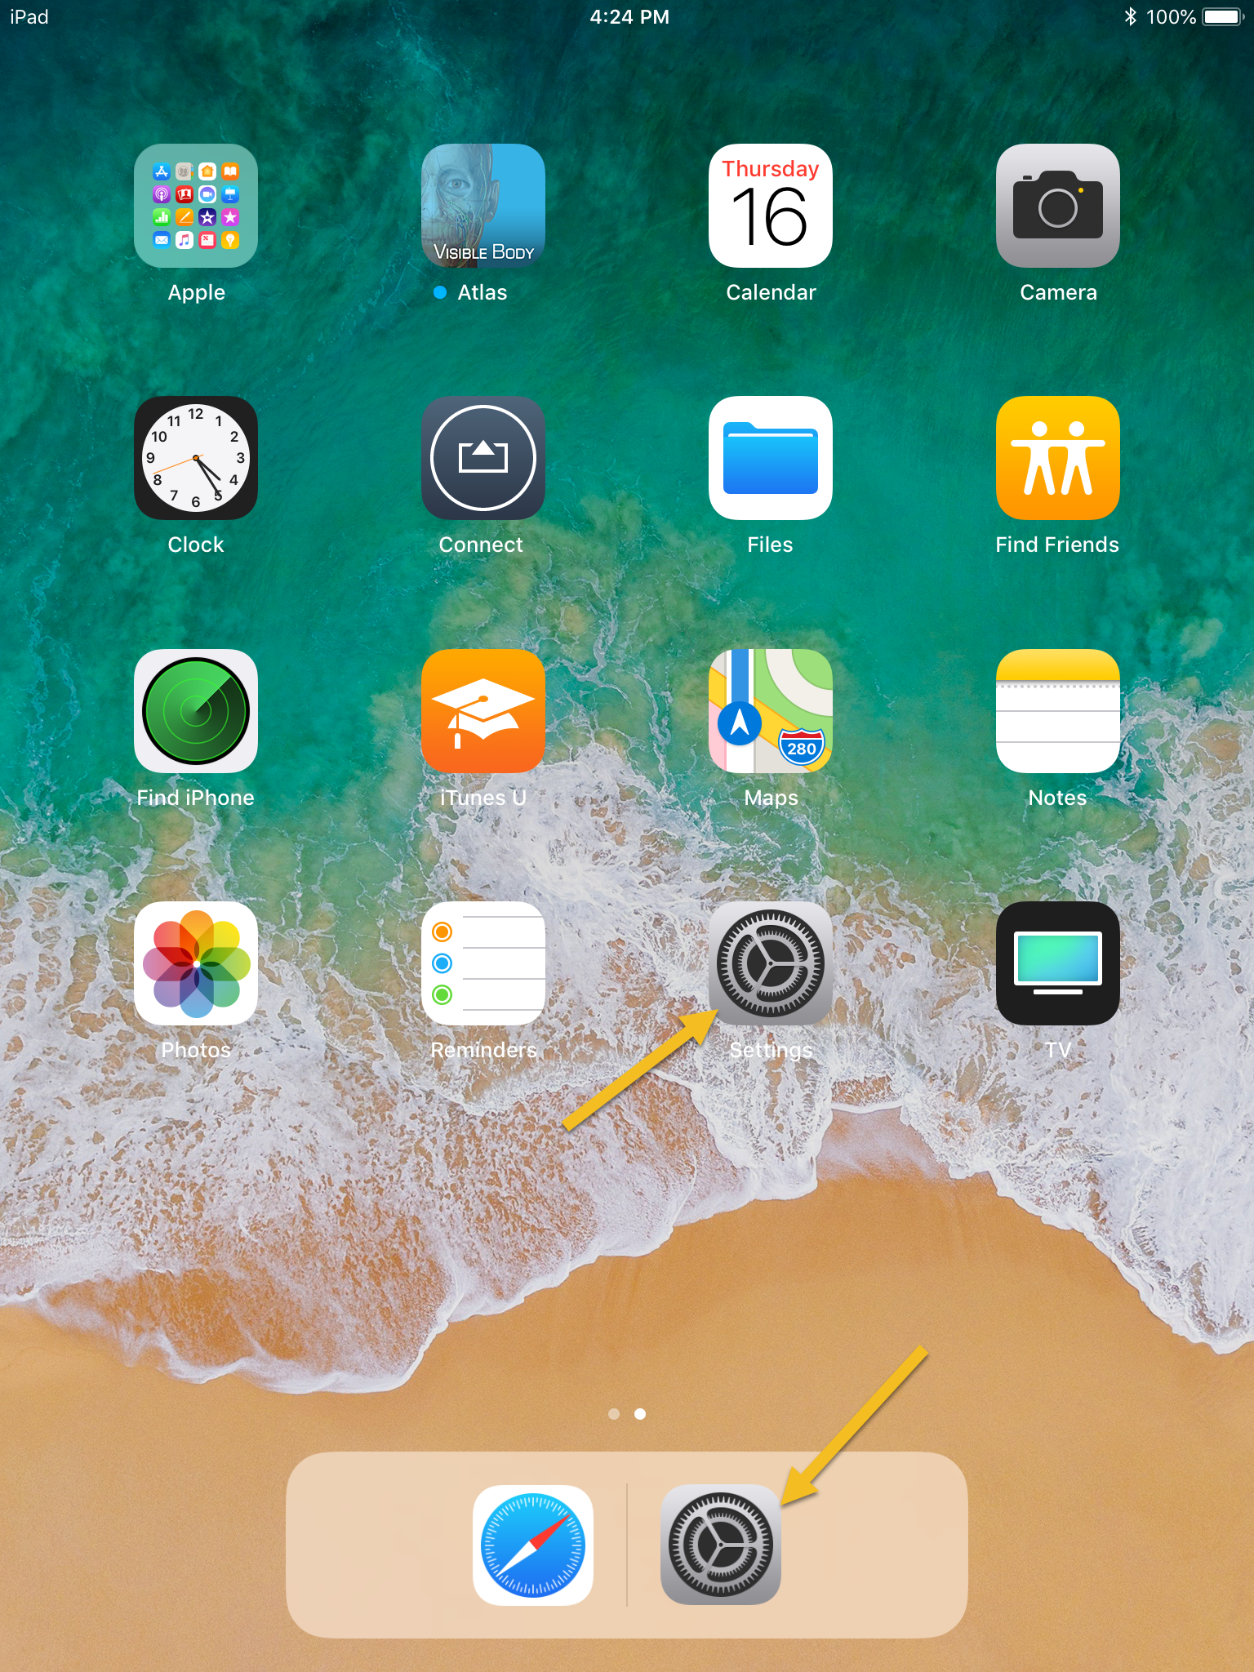
- Once you are at the home screen, select the Settings icon.

- On the left hand side of the screen, look for a bar that says Wi-Fi. Select the bar.
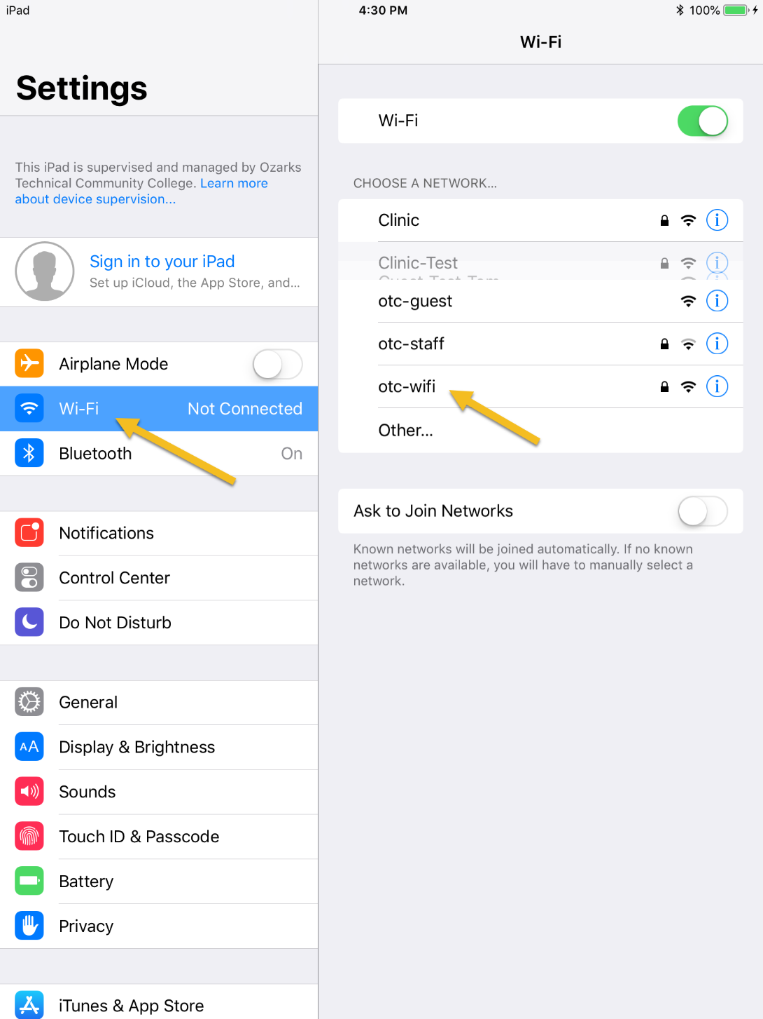
- On the right hand side of the screen a list of networks will appear, find the one that says otc-wifi and select it.
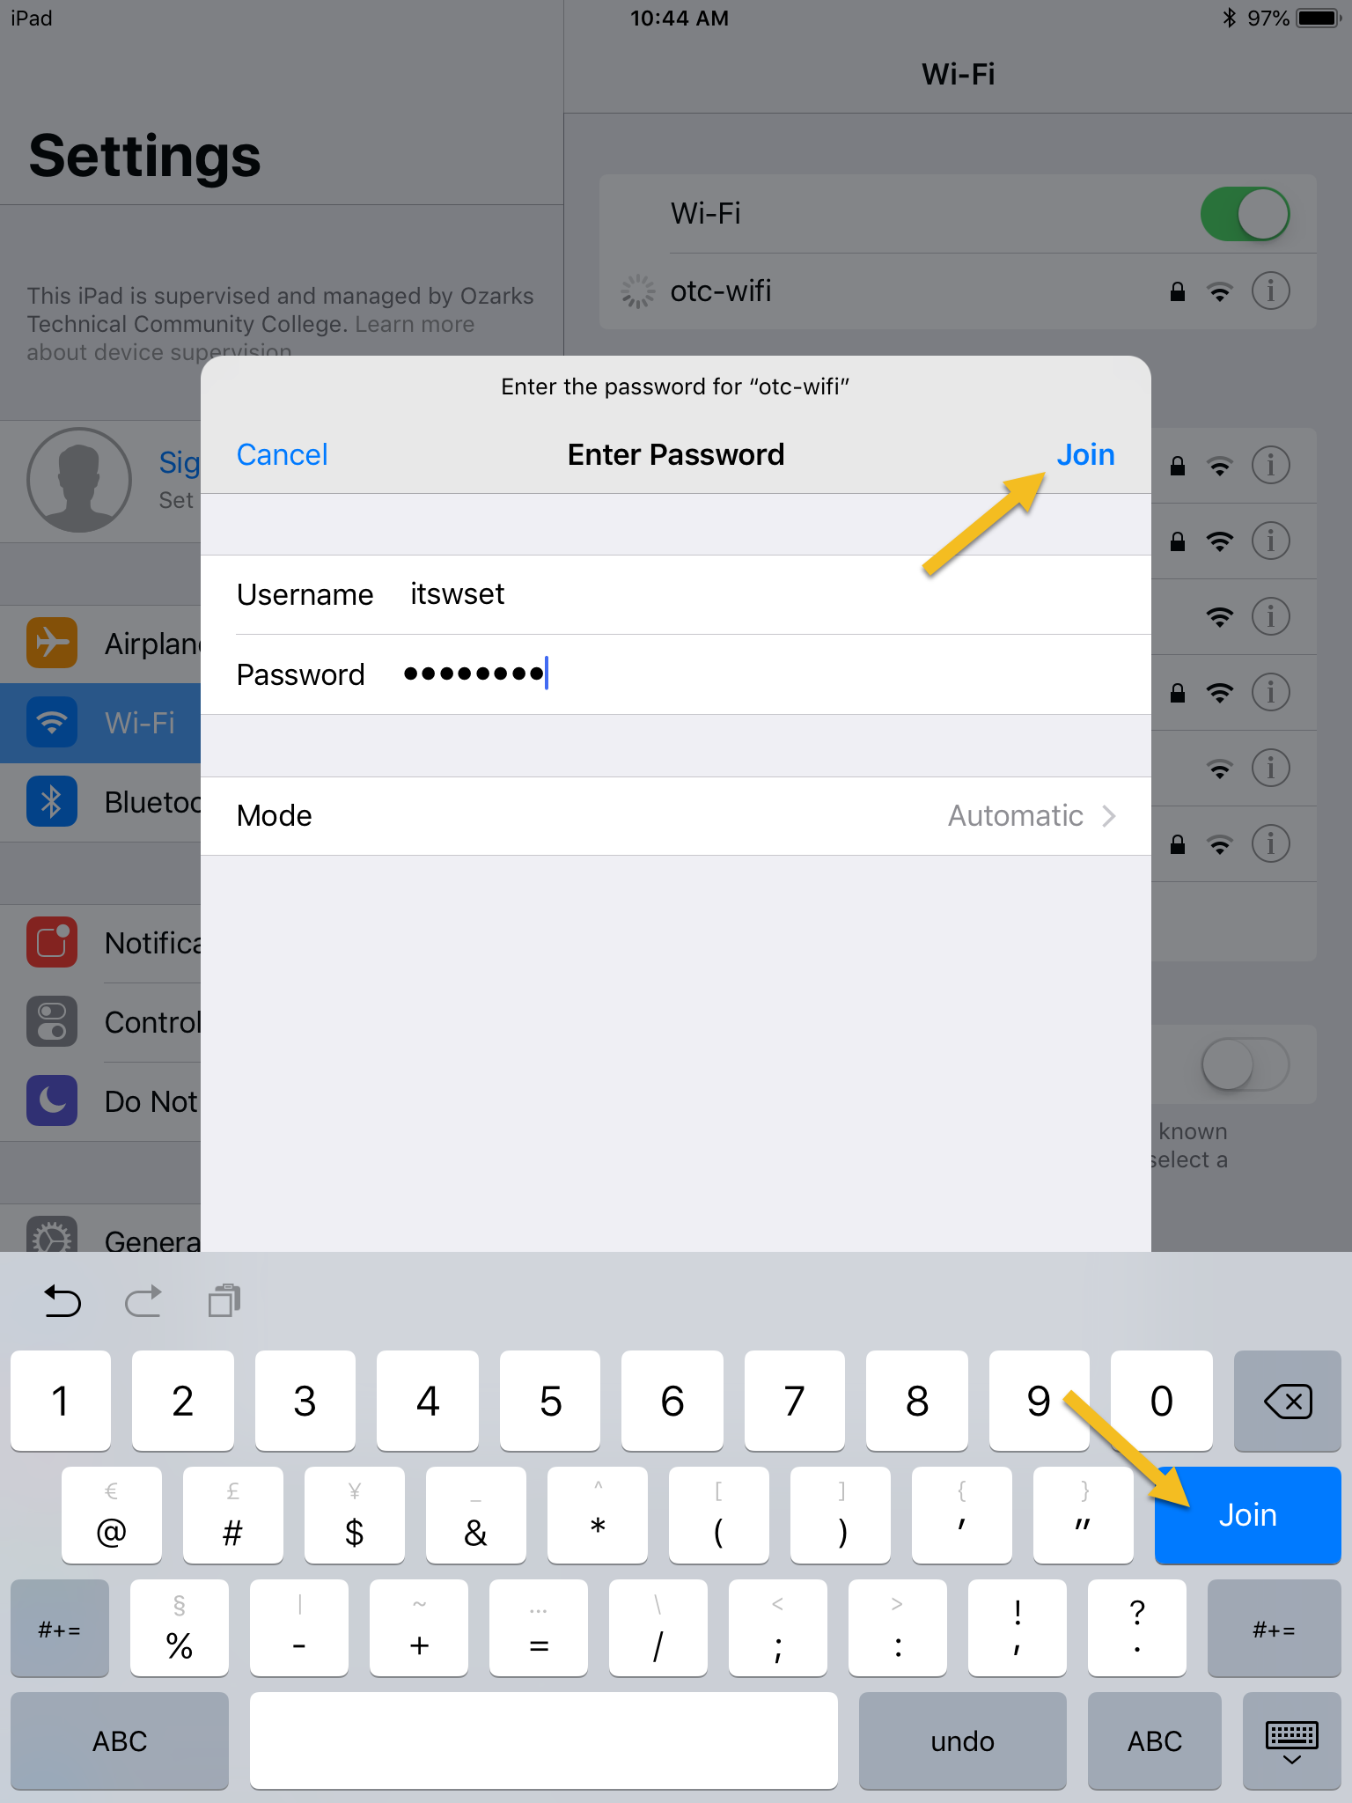
- You will be prompted to enter credentials, enter in your OTC credentials and select join.

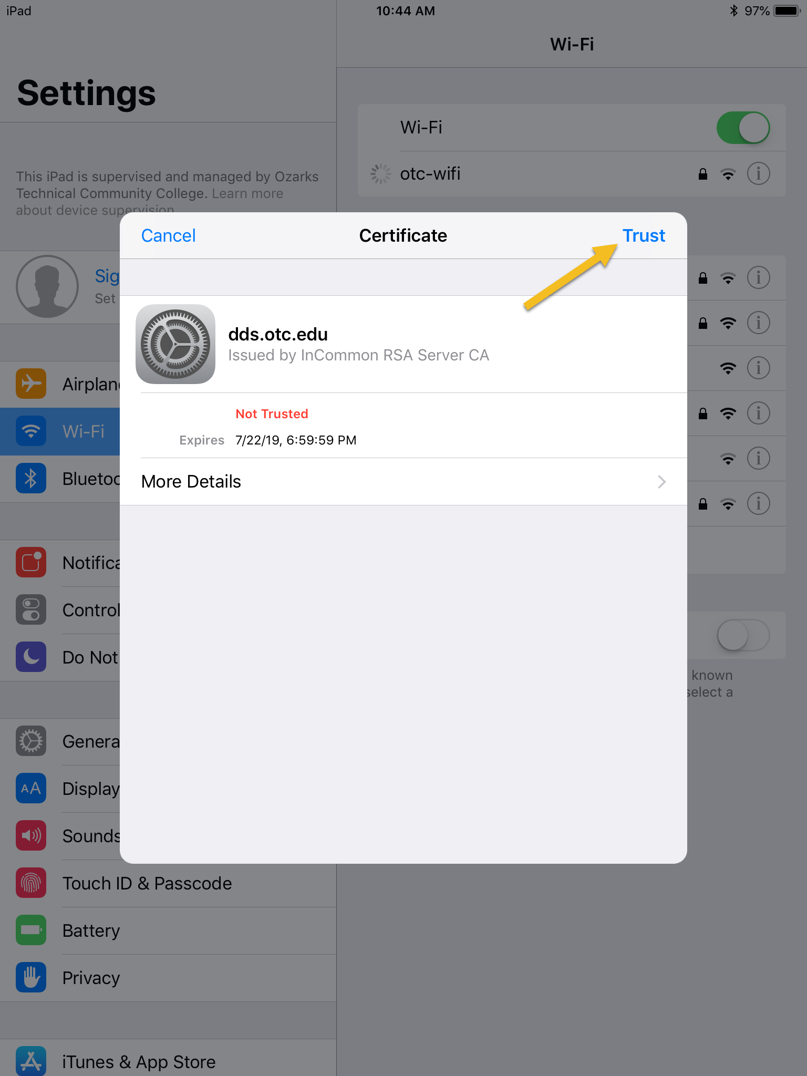
- A screen will appear asking you to trust the certificate, select Trust.

- Look in the upper left hand corner of the screen for the wifi symbol or a green checkmark next to otc-wifi. ; if you don’t see this symbol repeat steps 1-5.
- Once you are logged in to wifi, press the home button.

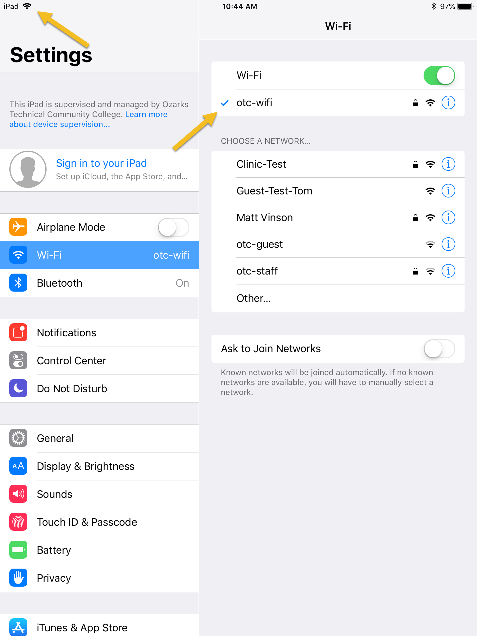

Opening the Visible Body App
- Once at the home screen, select the Visible Body Atlas icon.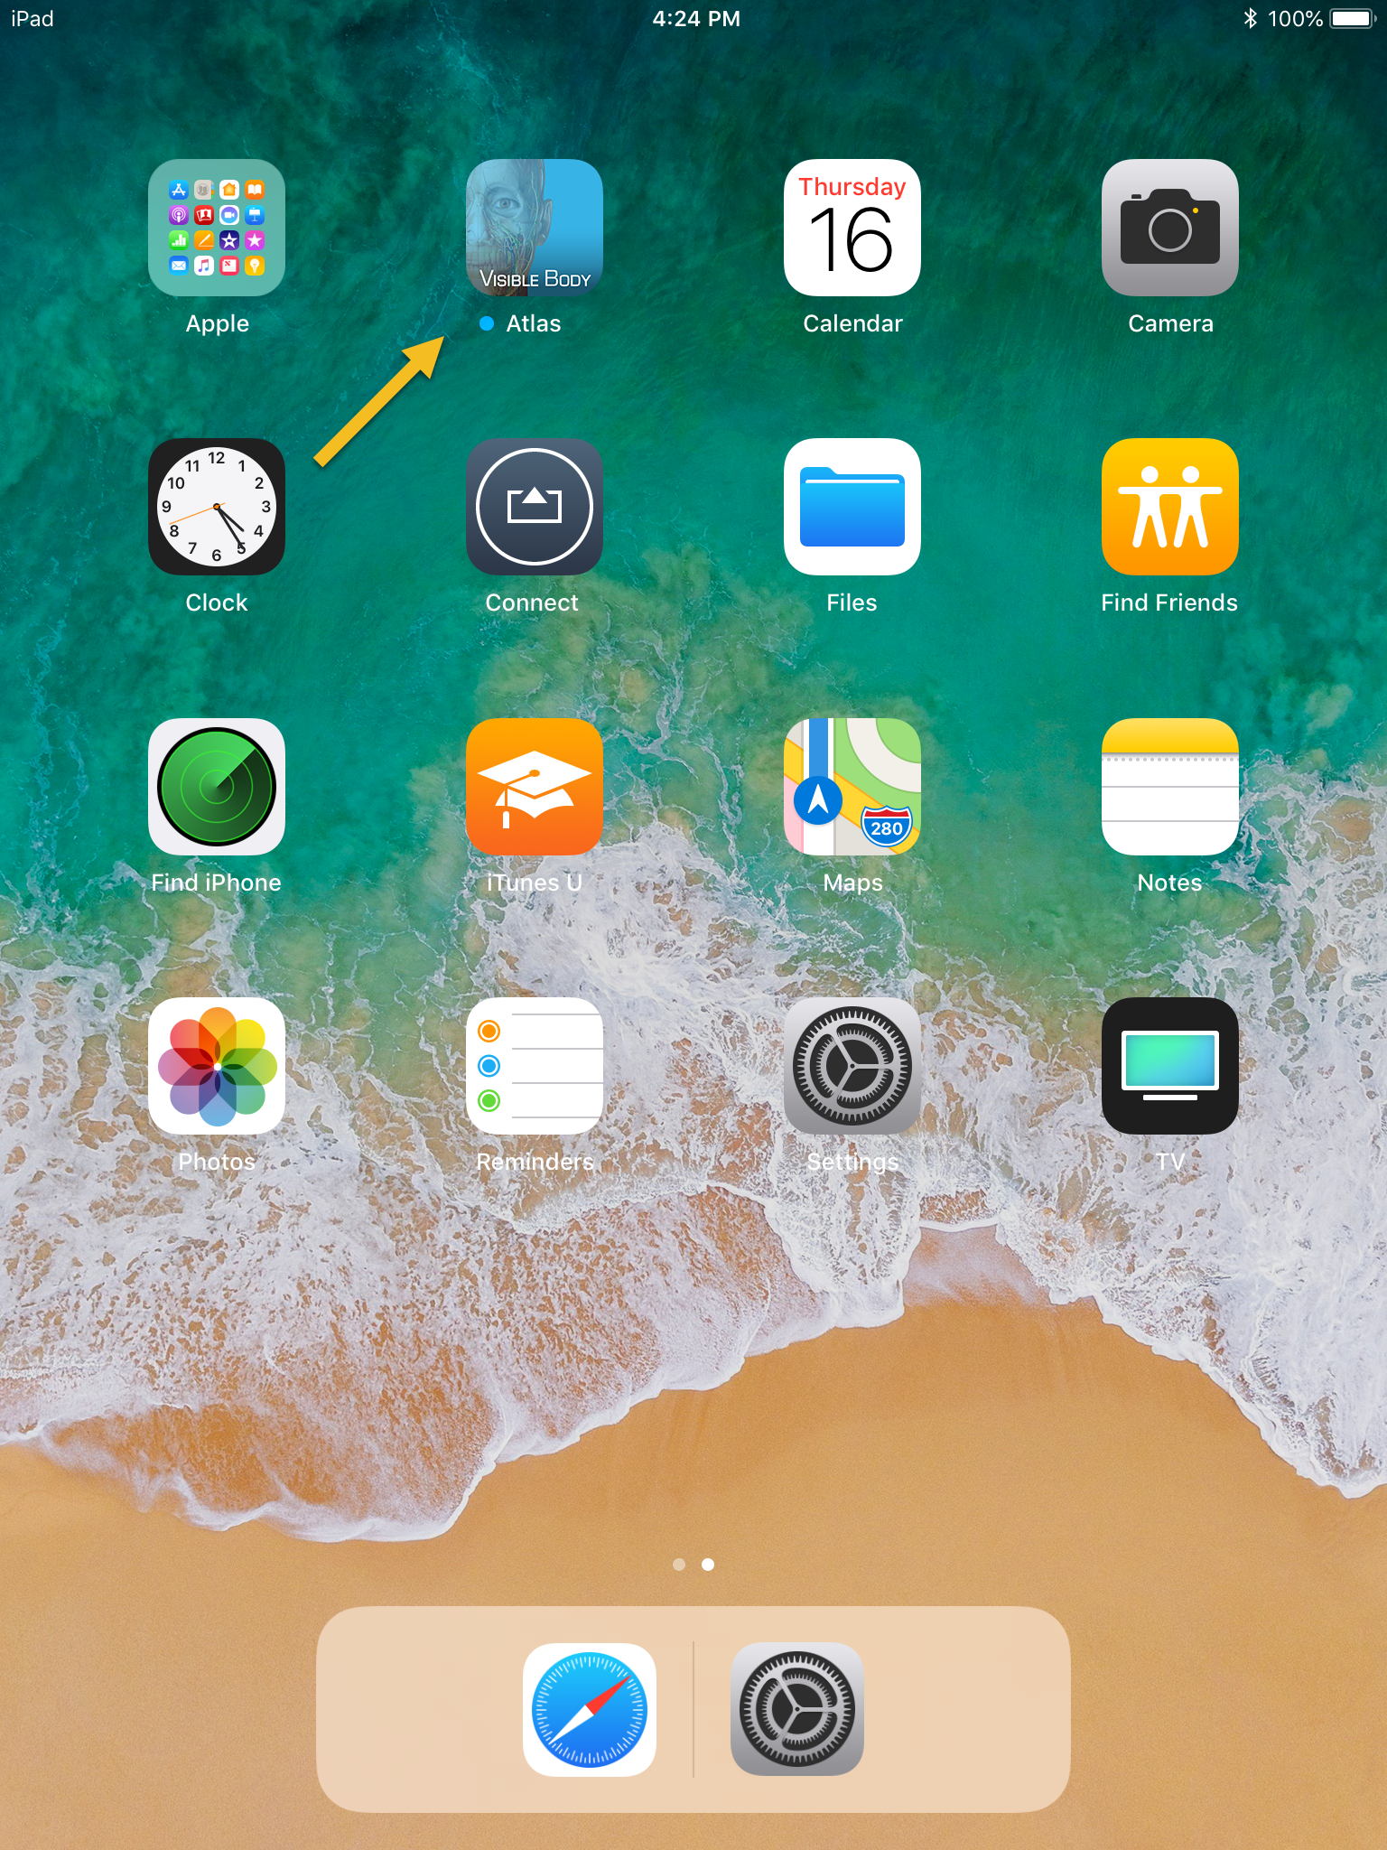

- You may see a screen saying “Your activation period has X days remaining.” Select OK.
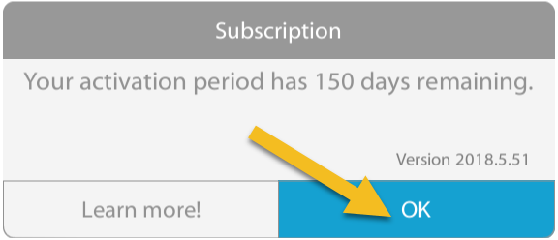

- Visible Body will now begin to load.
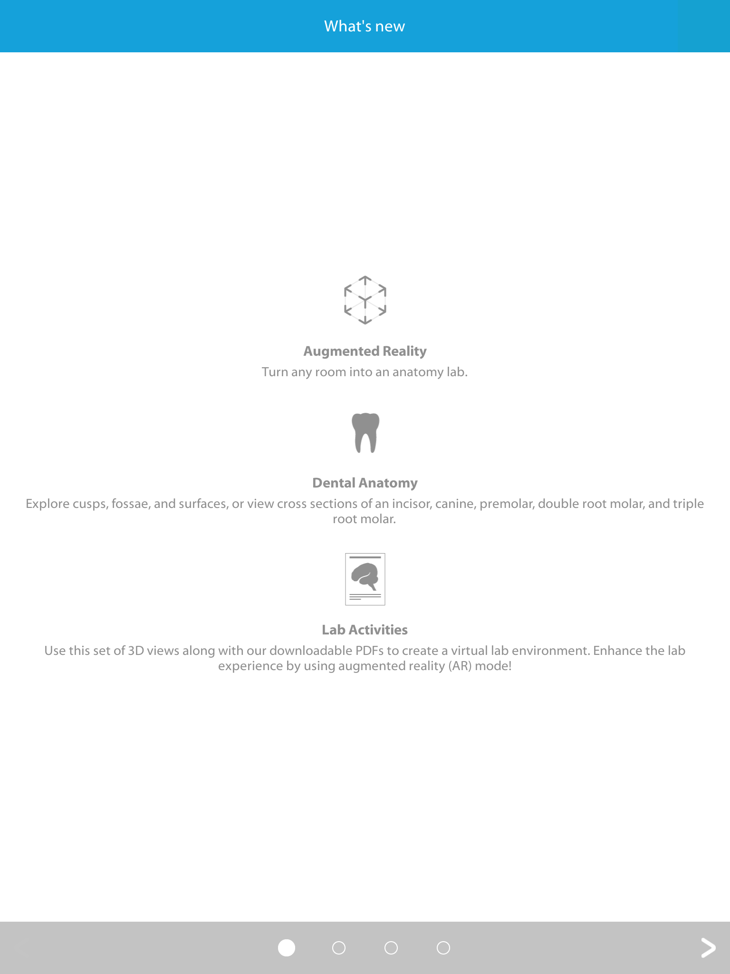
- You may see a screen advertising what is new in this version of Visible Body. Select the arrow in the bottom right hand corner of the screen to advance through the pages.

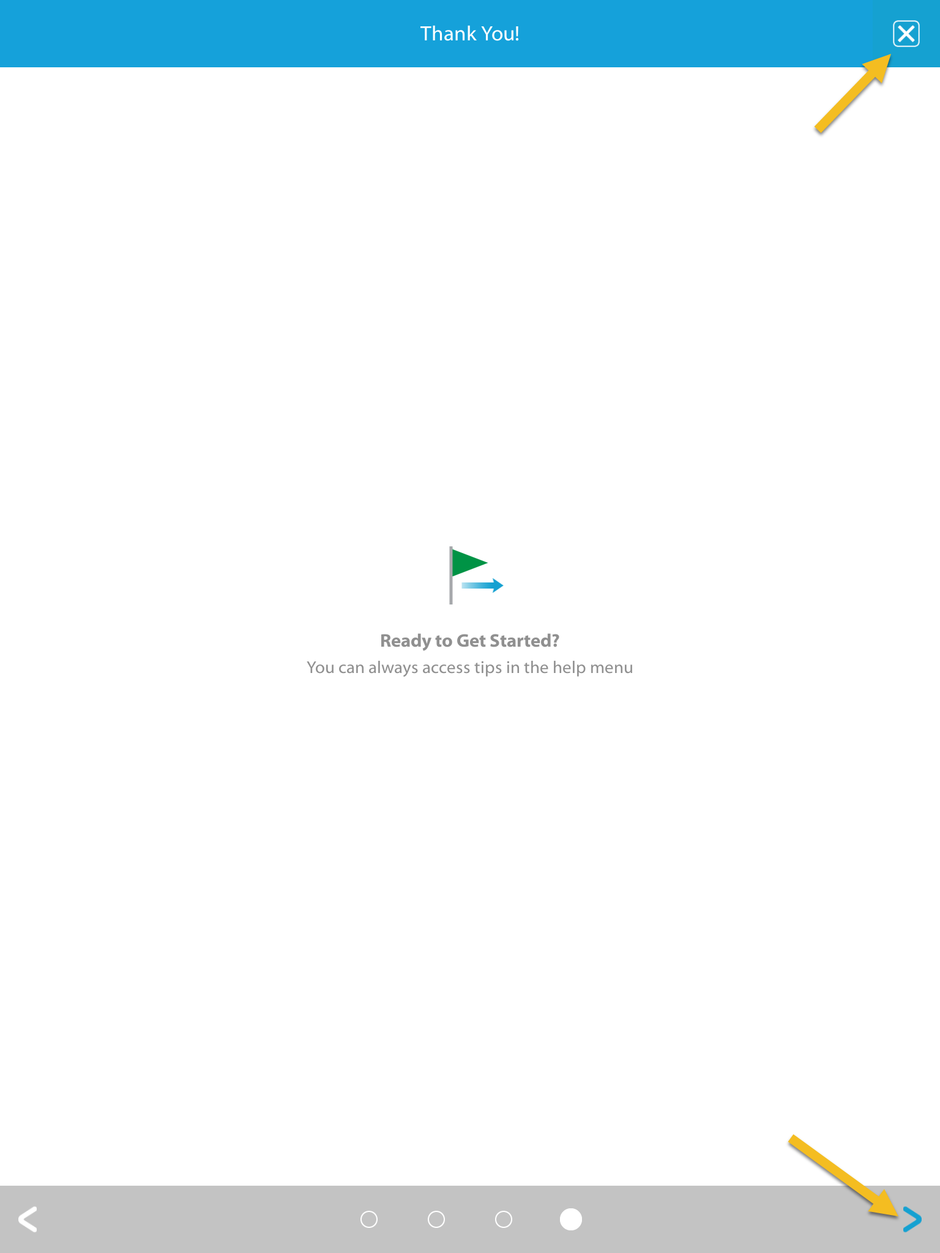
- Press the X the in upper right hand corner of the screen or the blue arrow in the bottom right hand corner of the screen to advance to the main Visible Body Atlas screen.

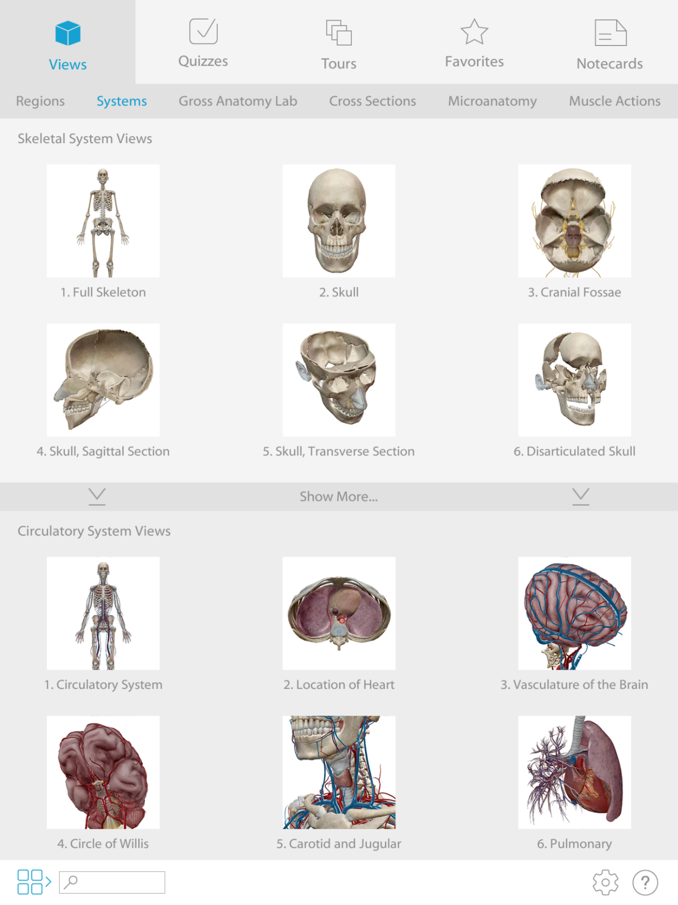
- You are now at the main screen for Visible Body Atlas.
Logging Out from OTC-wifi
- Press the Home button.
- Select the Settings icon.
- On the left hand side of the screen, look for a bar that says Wi-Fi. Select the bar.
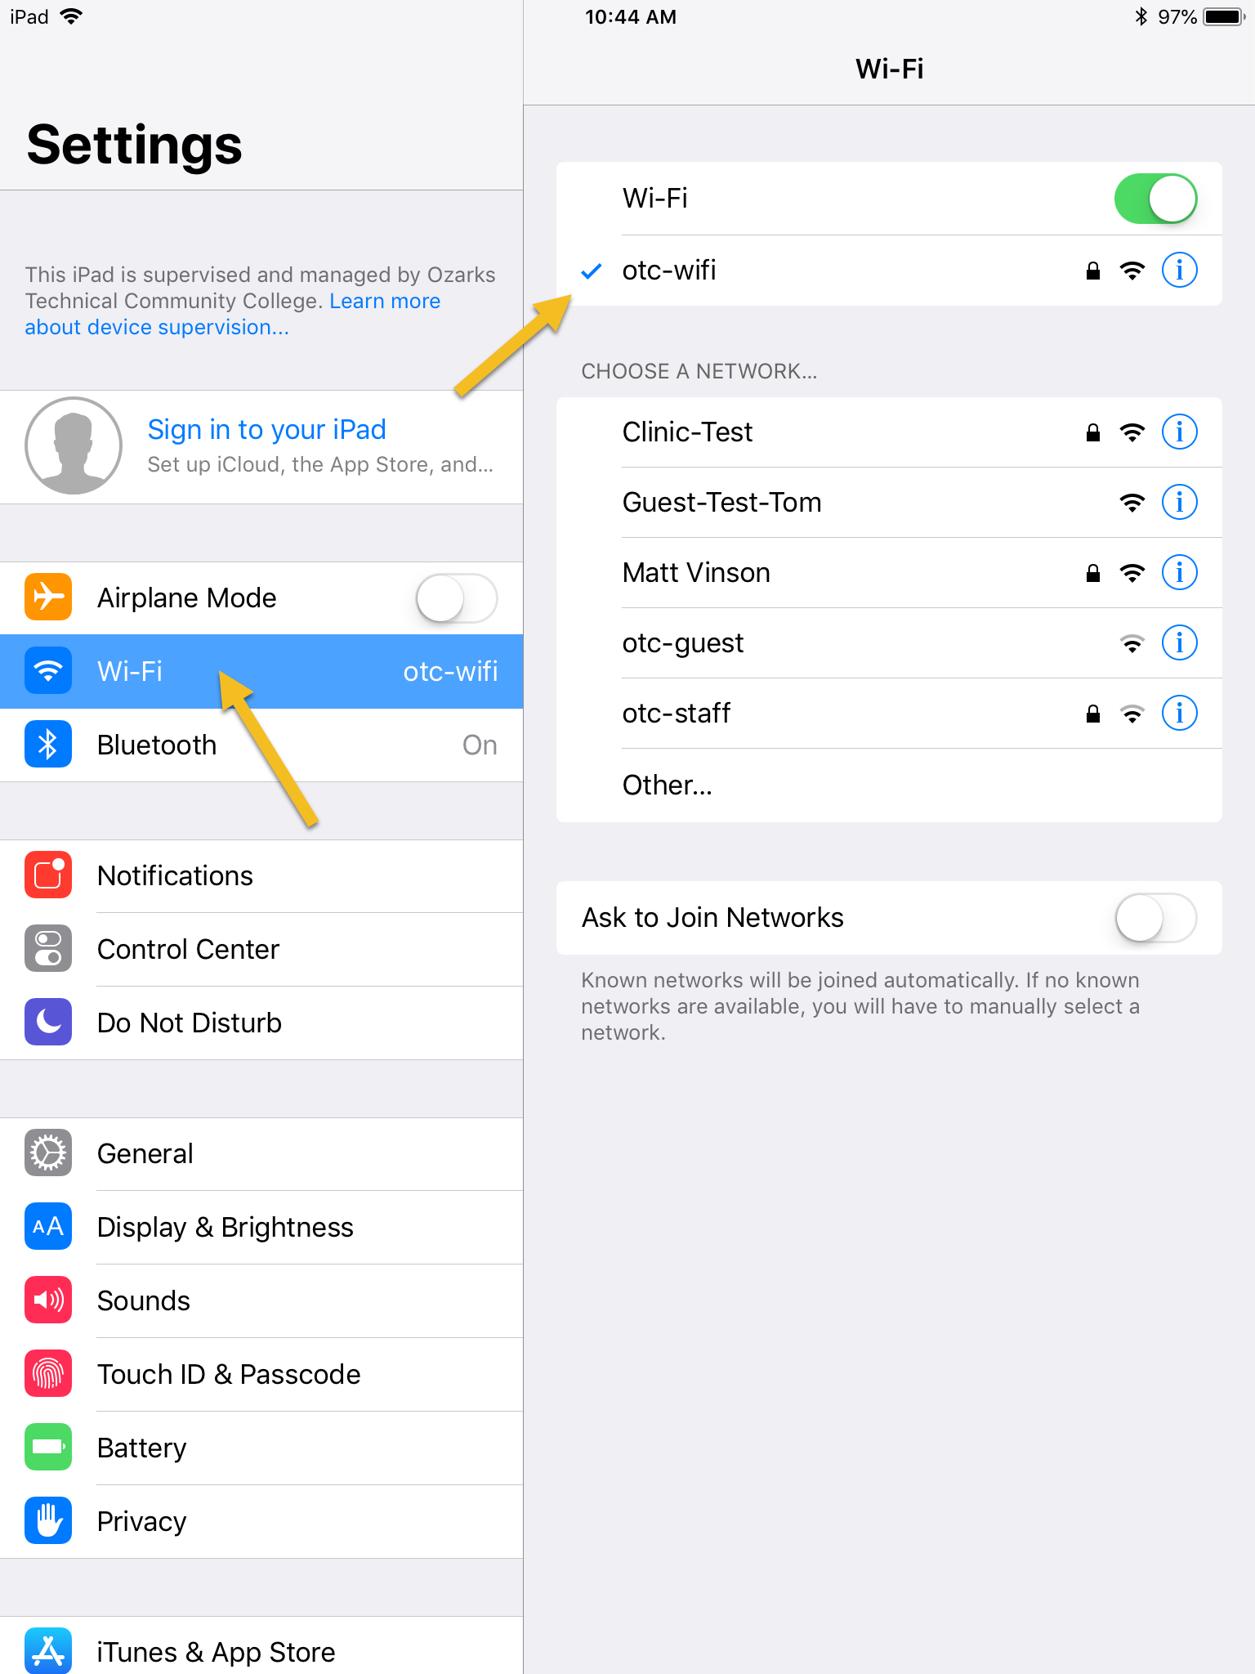
- On the right hand side of the screen, look for a bar with a blue checkmark next to it. It should say otc-wifi, select it.

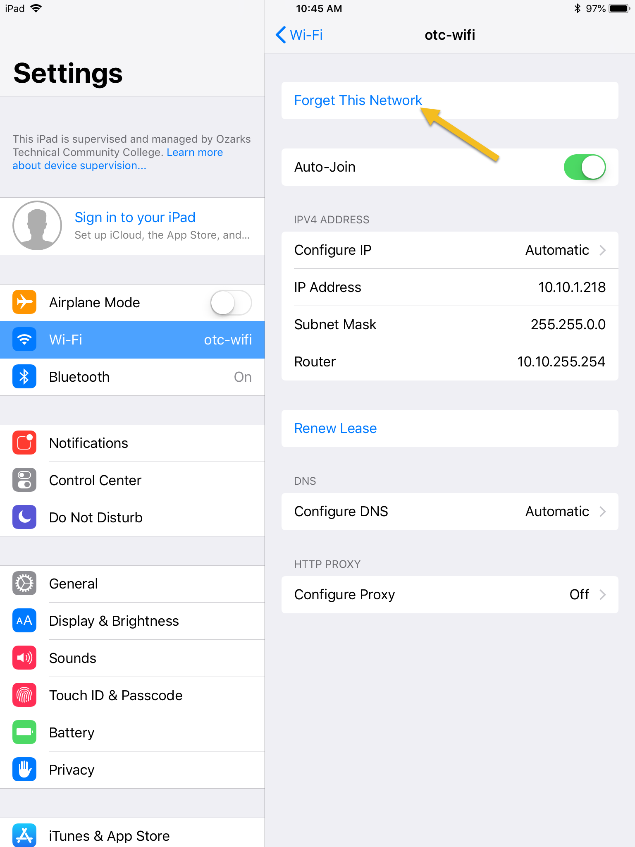
- At the top of the screen, look for a bar that says Forget This Network and select it.

- You will see a prompt that says “Forget Wi-Fi Network otc-wifi?” Select Forget.
- 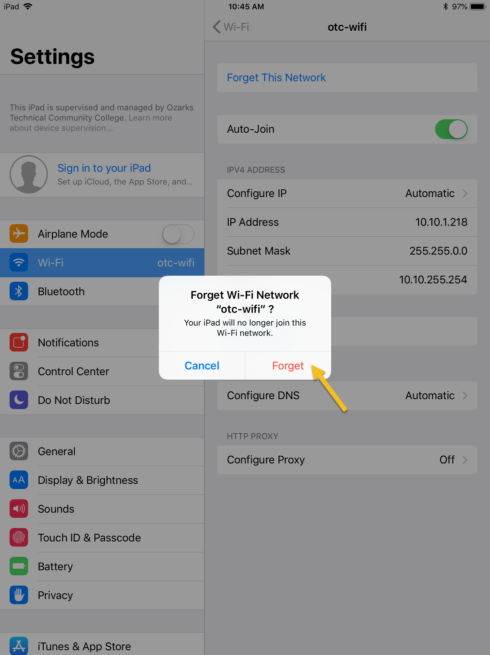
- In the upper left hand corner of the screen, the wifi symbol should be gone and the Wi-Fi bar should say “Not Connected”.
