Bioclinical Sciences (BCS)
Visible Body Atlas Guide
Tablet/Phone Edition

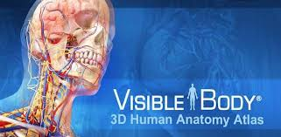*

* images courtesy of Visible body.
For a quick start guide go to: https://support.visiblebody.com/hc/en-us/articles/216842058-Quick-Start-Guide
Or for a short video: https://www.youtube.com/watch?v=6SR7qbeulEM

Open the Visible Body Atlas App. Don’t confuse this with the A&P App.
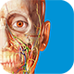 Atlas 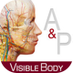 A&P
Once open the top row of tabs allows you to pick Views, Media, Quizzes, Tours, Favorites, and Notecards. We will primarily use the Tours tab where you can find premade images to more easily find structures. 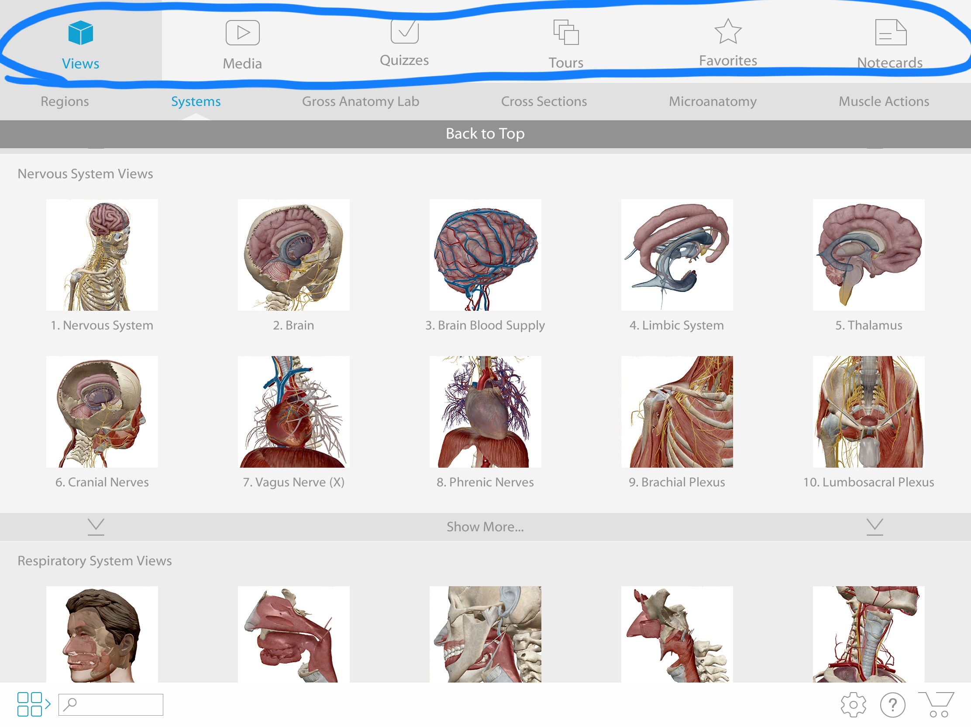

Touch/open the Tours tab and the available Tours will open. We will touch/open the Circulatory System Tour to use as an example. 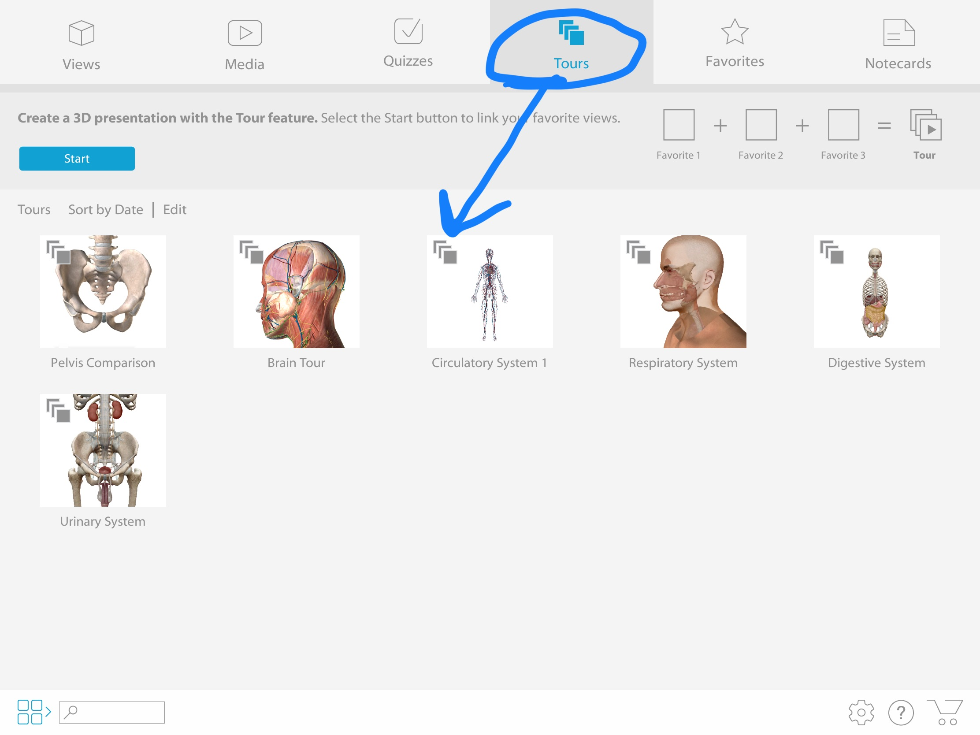

Once open it will bring up view 1 of 8. You can move through the views by pressing the forward or back arrows. Use two fingers on the screen at the same time to move the view up and down. Use one finger to rotate the view. You can use two fingers to pinch to zoom in or out of the view.
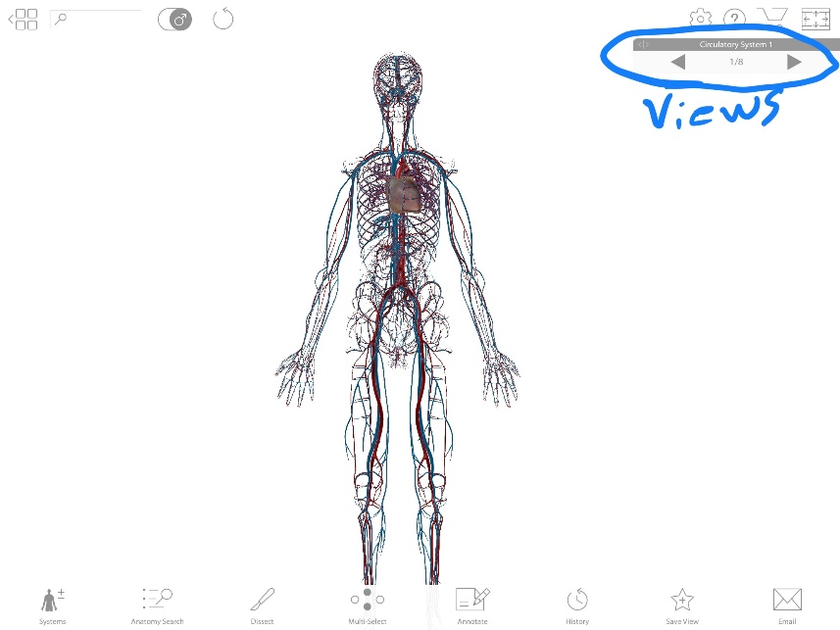
Move forward to view 2 of 8. Each different view will give a better perspective of a set of different structures. View 2 highlights the major vessels coming off the heart. In order to see the name of the vessel simply touch it. The Aortic arch has been touched. A list of all pertinent structures to identify can be found in the lab manual
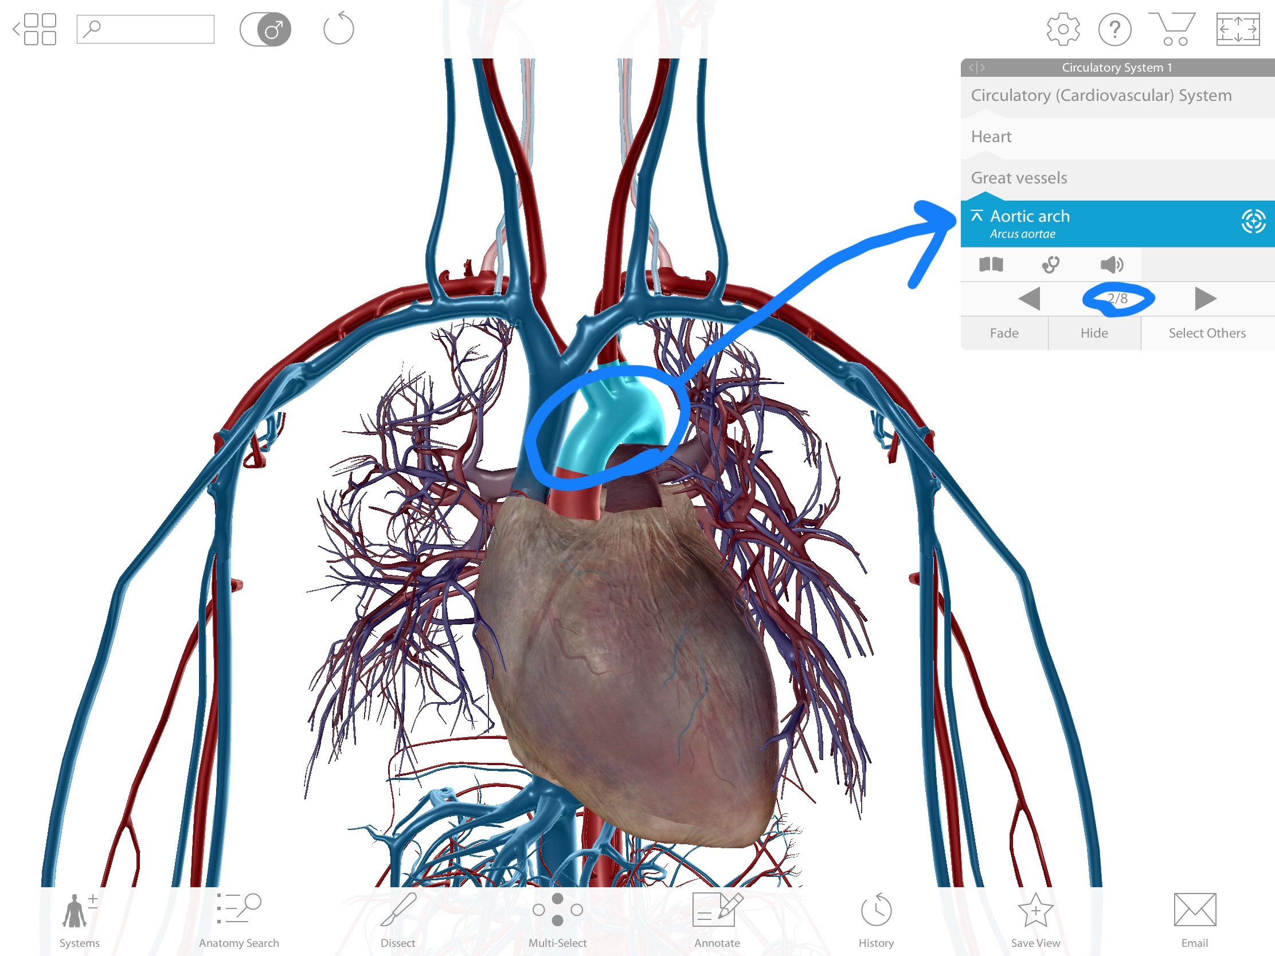

(NOT Mandatory) Using the bottom row of tabs which consist of Systems, Anatomy Search, Dissect, Multi-Select, annotate, History, Save View, and Email you can manipulate the views which can be useful but is not required. With the Systems tab you can add or take away entire systems. Here I have added the Respiratory system. You will notice that both veins and arteries of the circulatory system are also chosen which was the original view. Anatomy Search tab can be used to search for structures (some will have an “ADD” button that will allow you to add them to your view. If the structure is too far away it may only have a “Go To button” that will give you a view of the structure). The Dissect tab will dissect/take away structures/layers. You can choose to simply fade the structure you want to dissect or completely hide it with the Fade/Hide buttons highlighted. If you choose the Multi-Select tab you can choose multiple structures to dissect/fade/hide all at once.

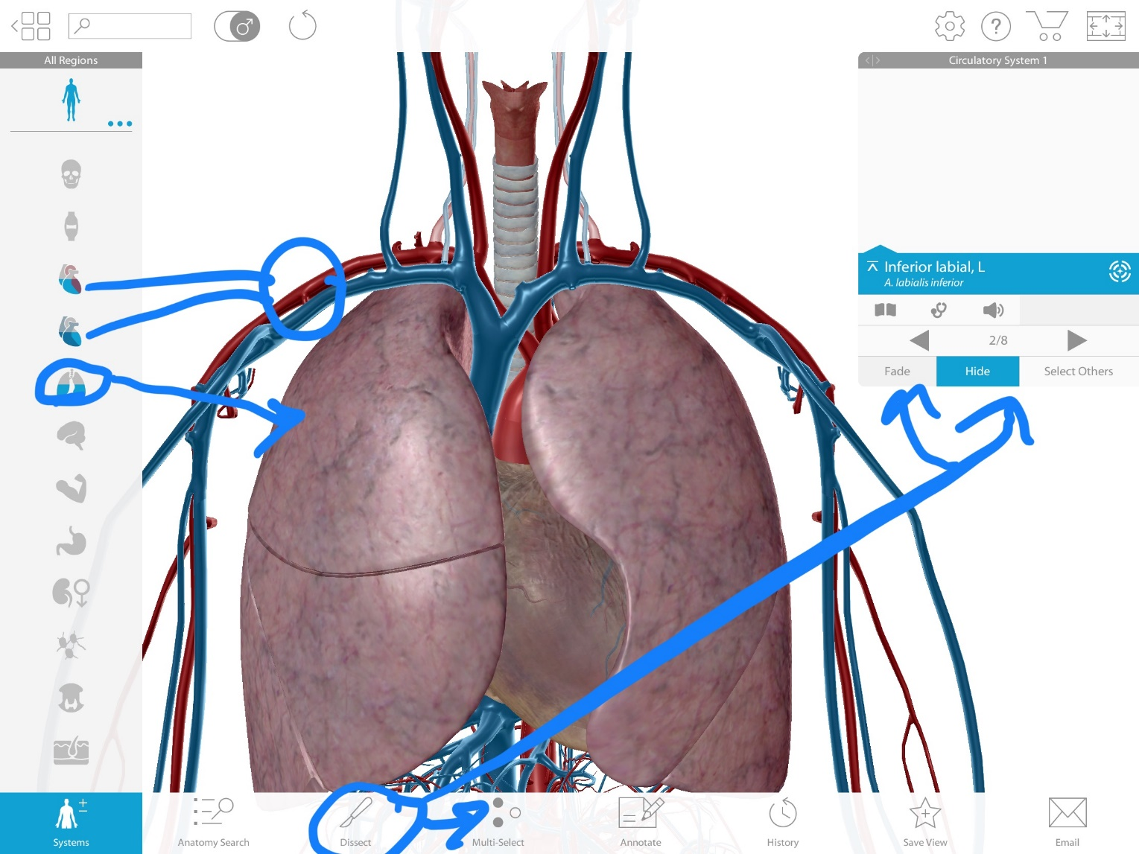

The Annotate tab will allow you to draw or make a note on the view. You can also save notes/drawings here.
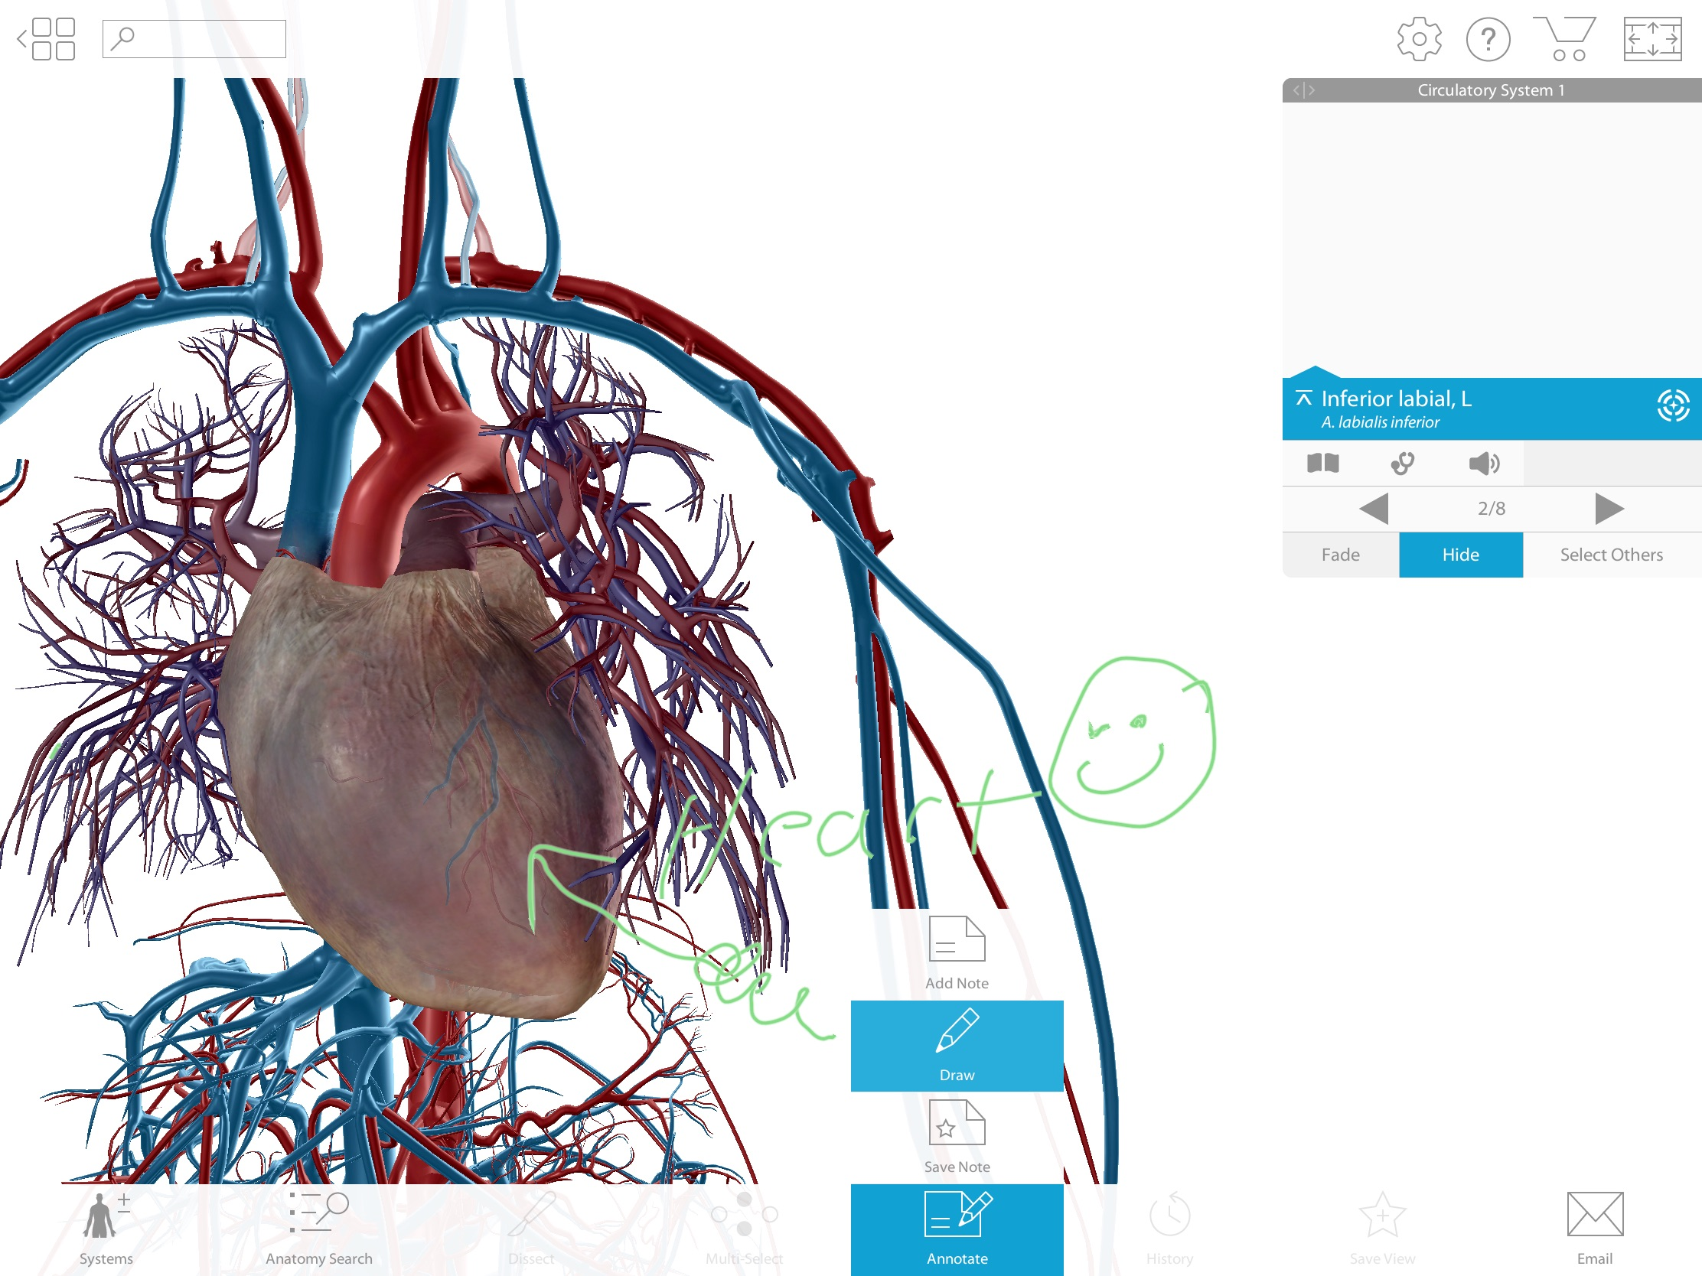
Don’t worry if you mess something up you can always go back/undo using the History tab and it will undo what you just did. The top undo tab will undo the last thing you did and the refresh tab will refresh the entire image to the original view.
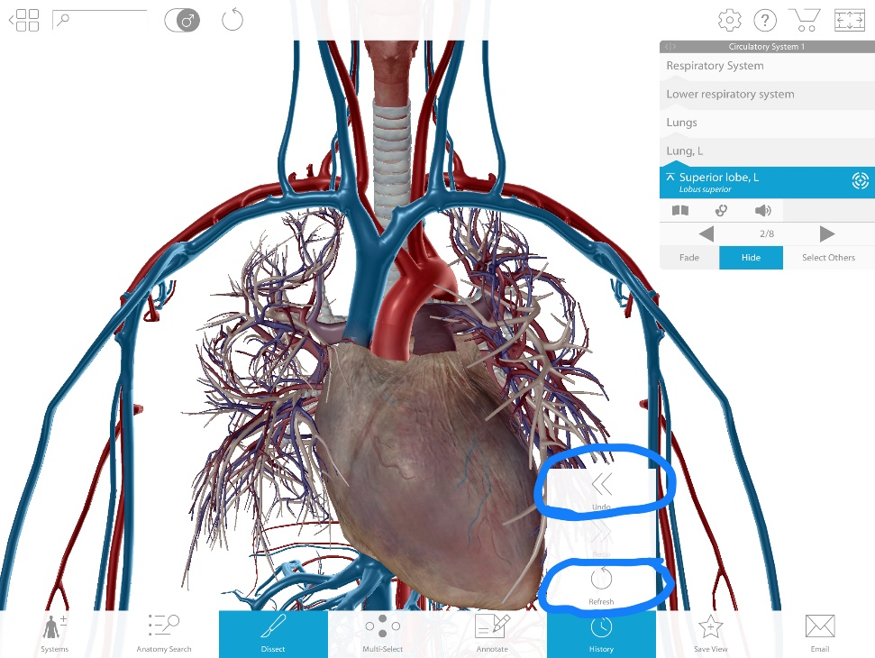
The Save View tab will allow you to Save a View you have created, or marked on, for later use and the email tab will allow you to email a view to others or yourself. 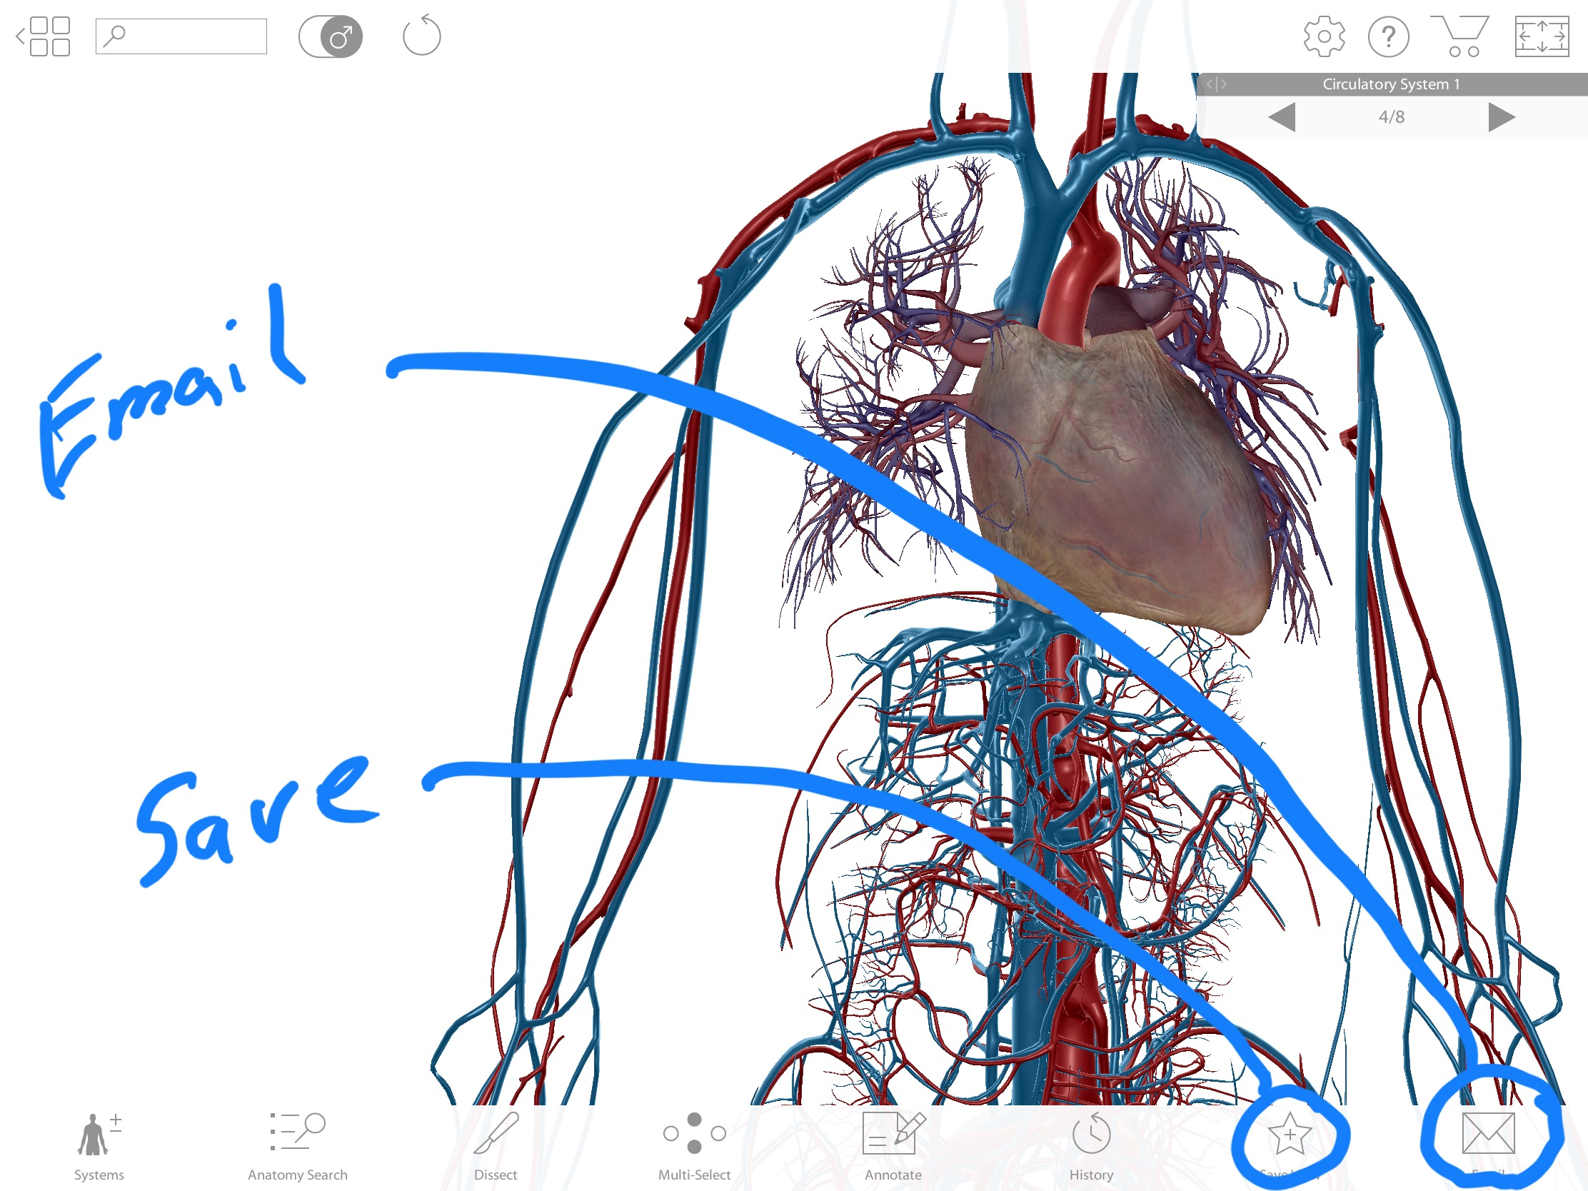
When finished with a tour or to find a new view simply touch the four small squares with the back button in the upper left corner of the screen to return to the main menu.
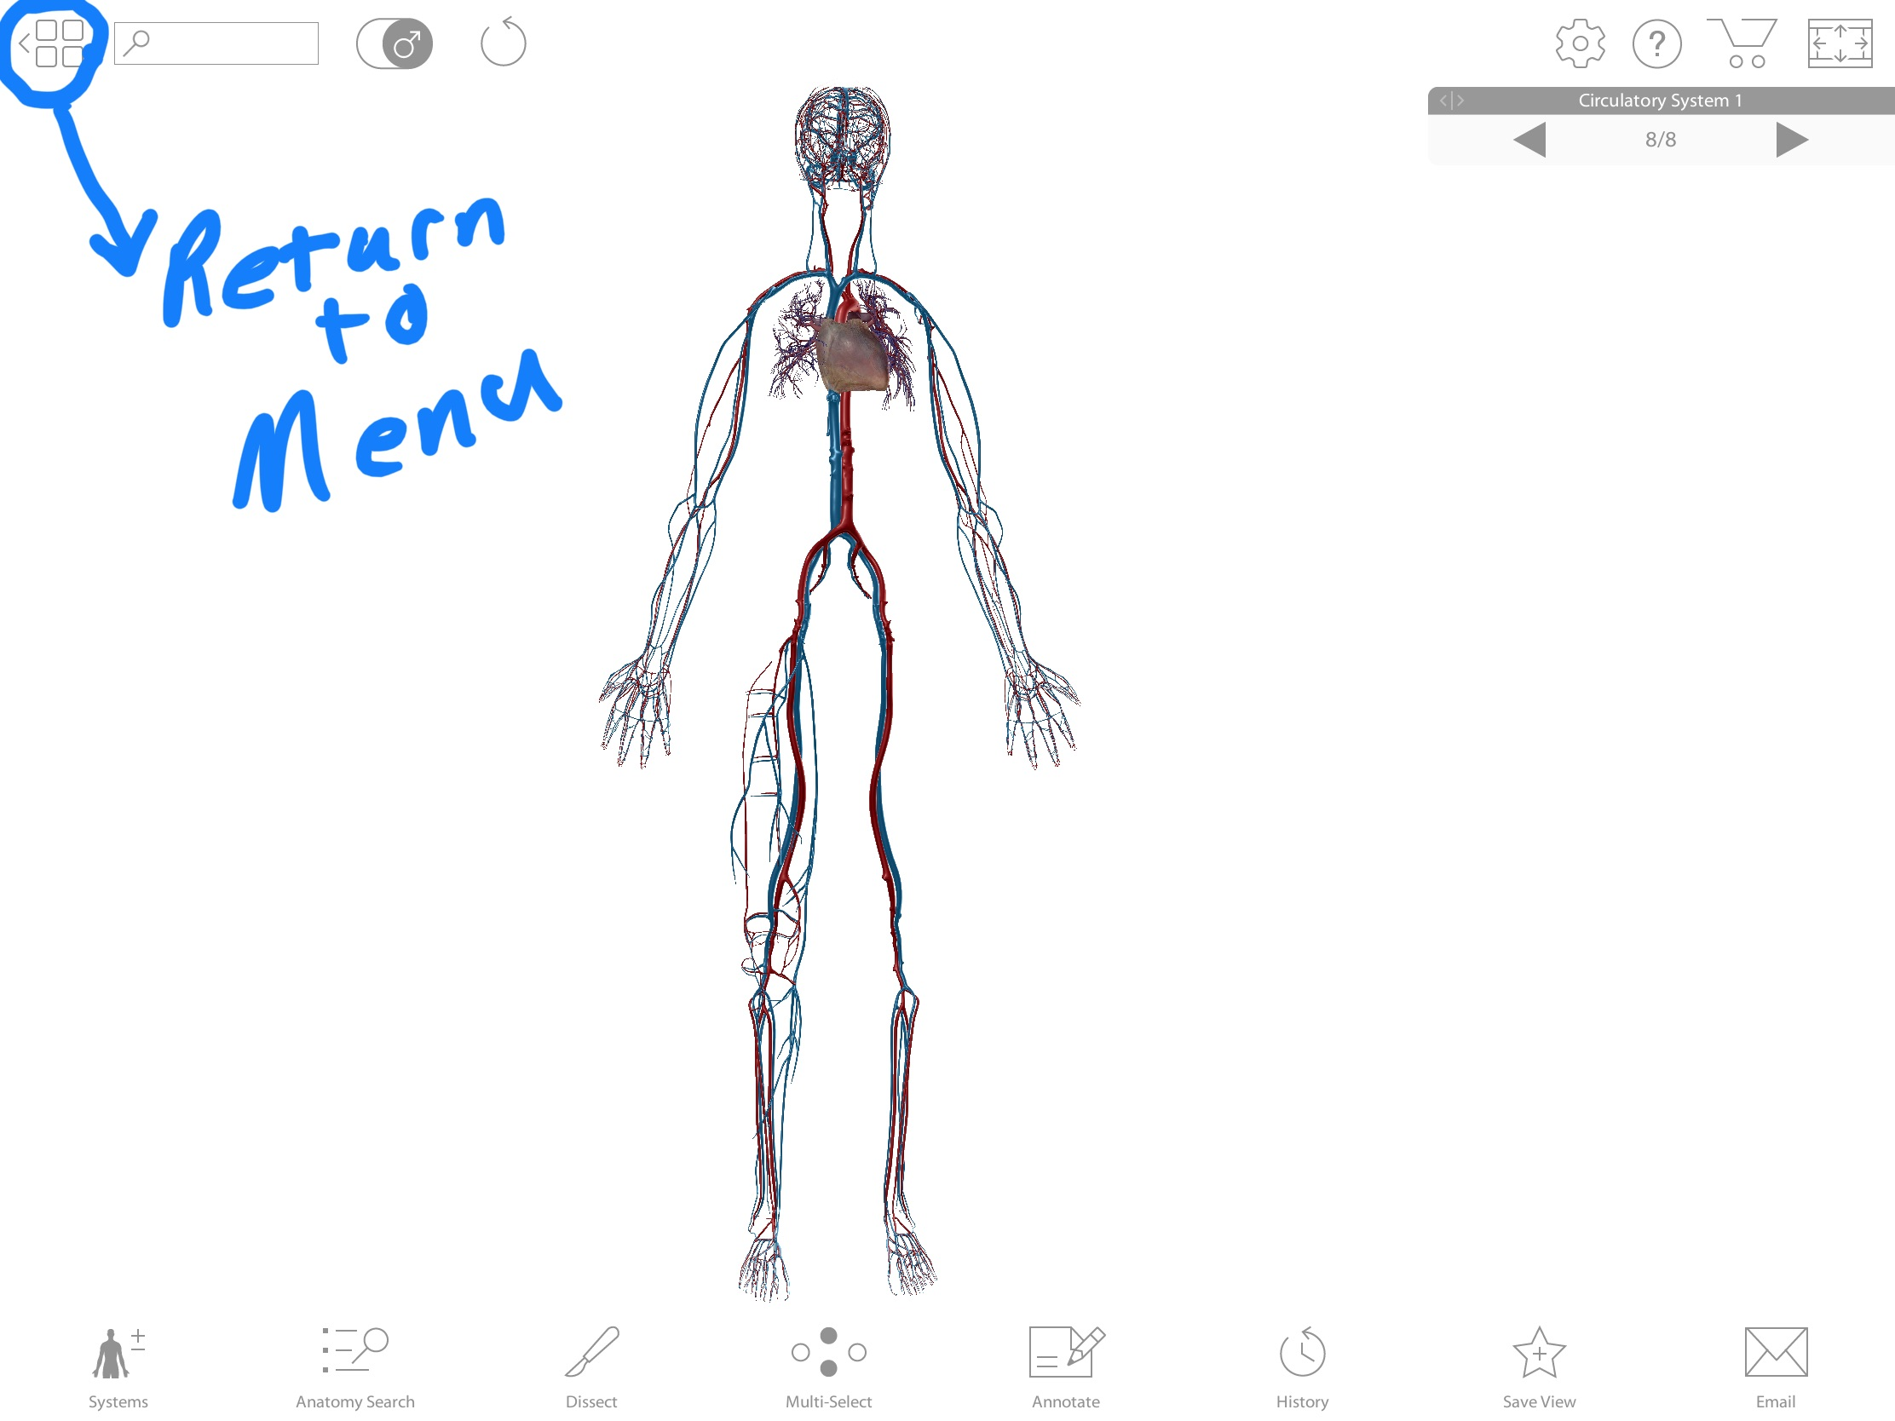

To use the Augmented Reality feature you can pick your own view or go into favorites to choose a view from the main menu. If using Augmented Reality in the lab the correct view to pick will be described in the lab manual. Here I will open up favorites and choose the saved Vessels of the head and neck view.
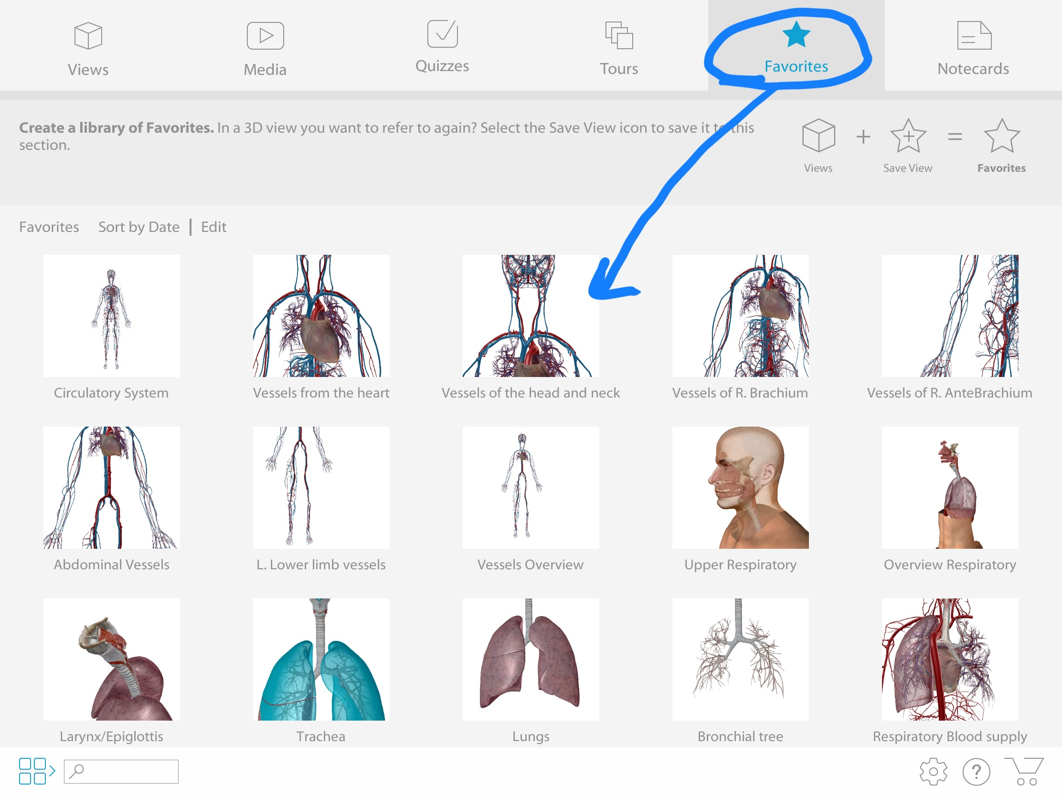
Once that view is open touch the Augmented Reality box. 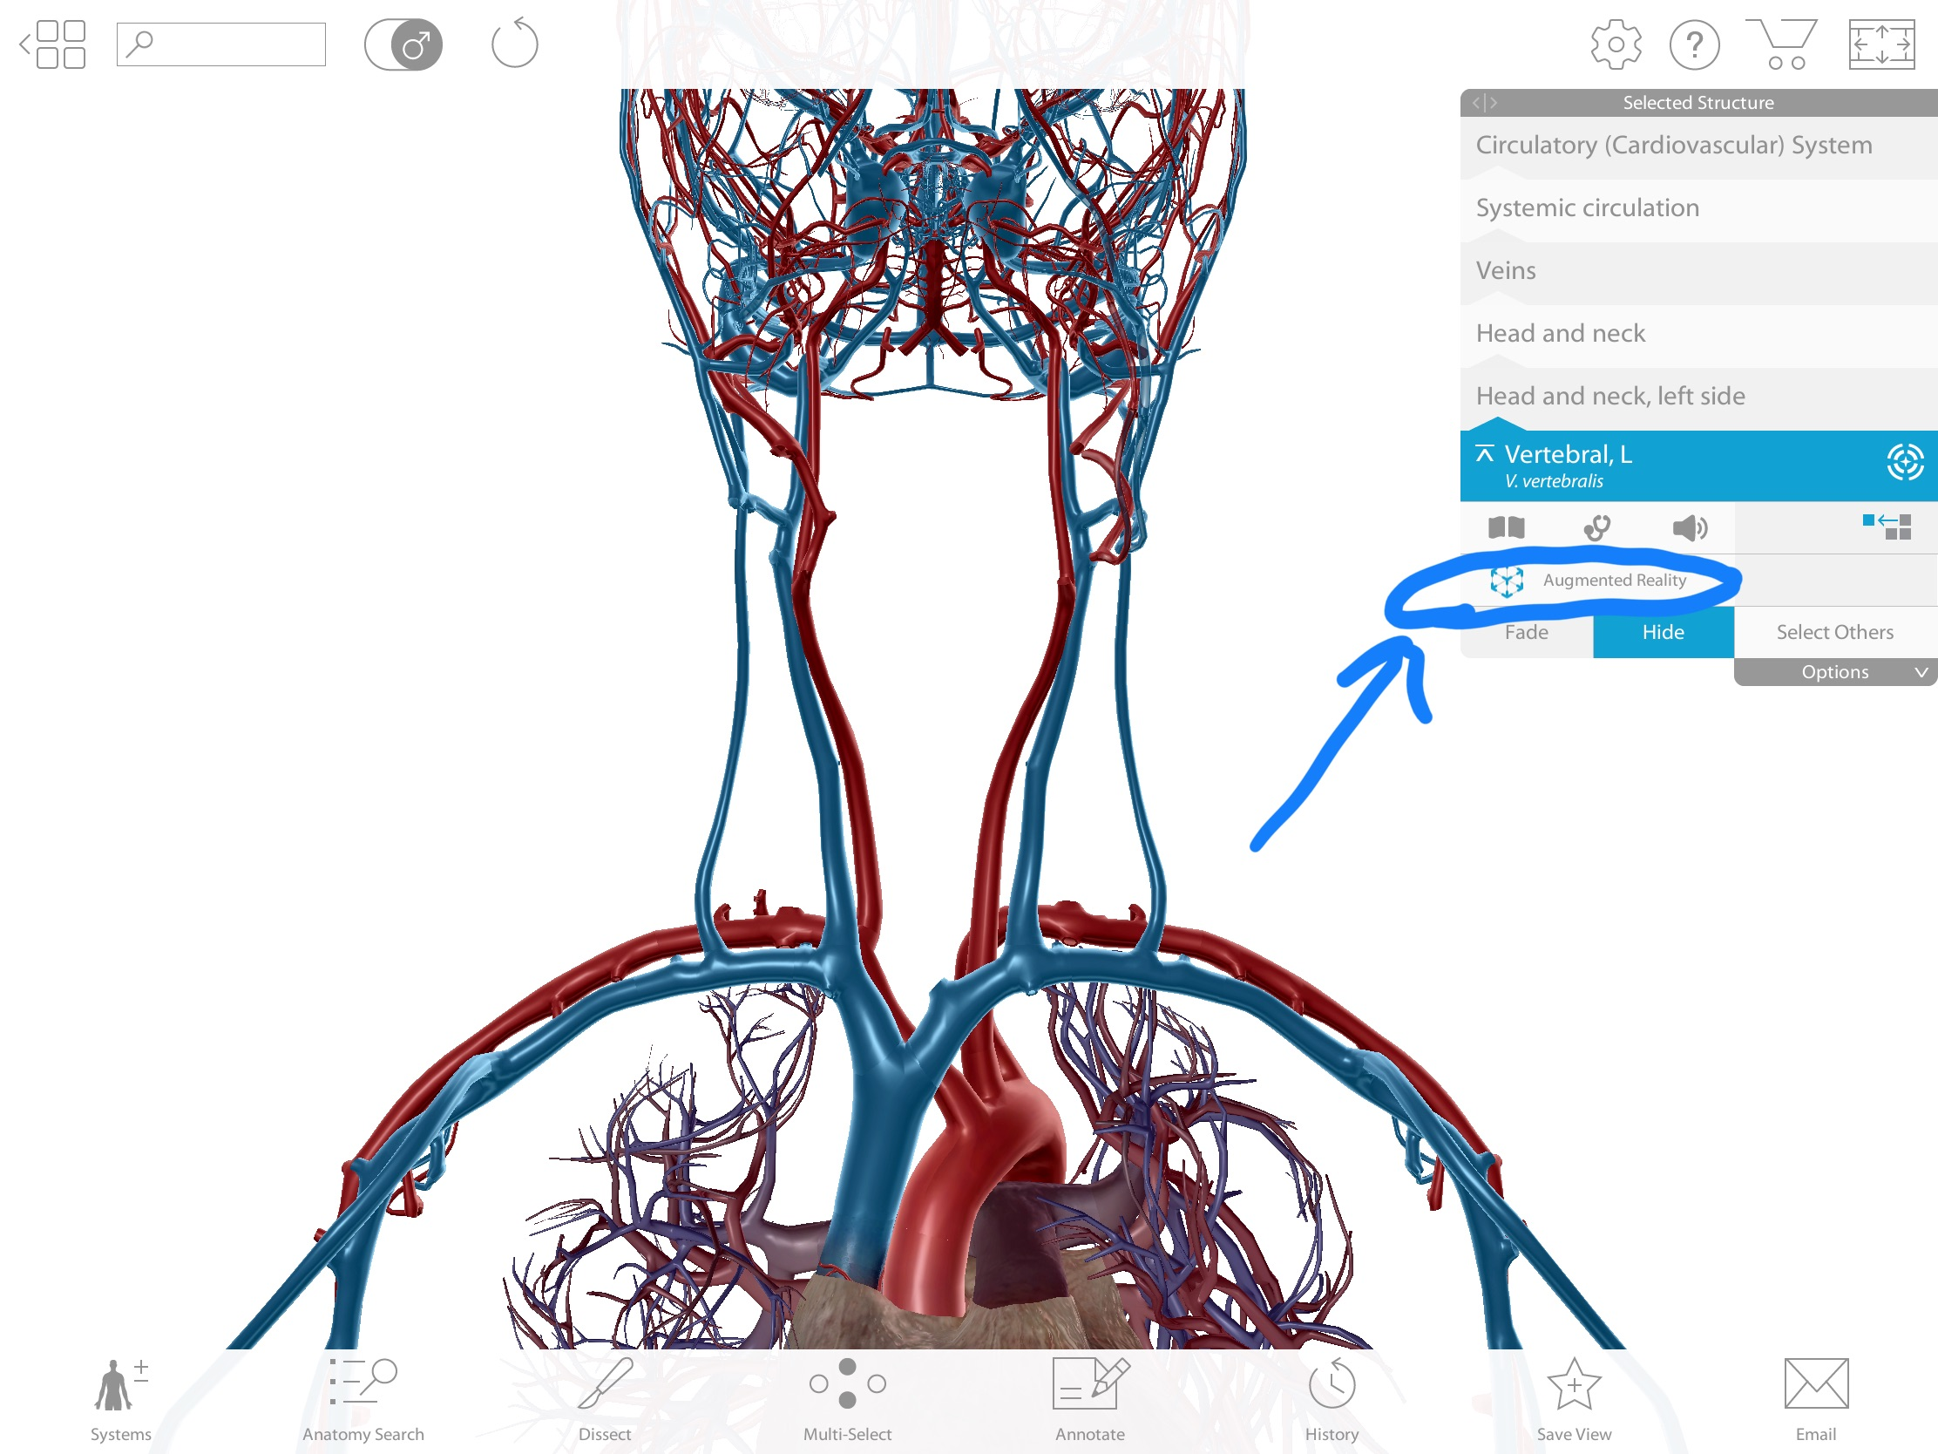

This will turn on the camera to the tablet/phone and allow you to scan the surface you want to project the view on. Move the tablet from side to side to scan the area. Once scanned a yellow box will appear. You can tap the yellow box to place your model in that location.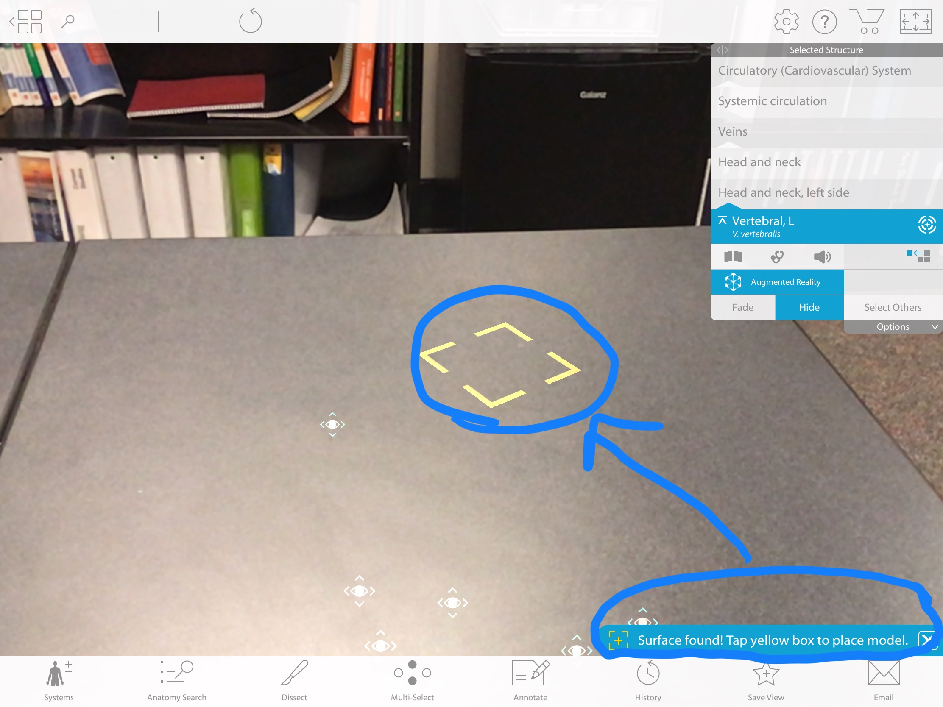

Once the model/view is placed you can adjust it by using two fingers on the screen to move it up/down and left/right. You can pinch in and out to make the model larger or smaller. You can use one finger to spin/rotate the model. Once you have the model in the desired position you can walk all around it, bring the tablet closer to view structures in more detail, or move further away to get a better overall view of the model. As in normal mode you can still touch different structures to highlight the name. Here you can see the heart/pericardium that is highlighted from a Superior left lateral view. 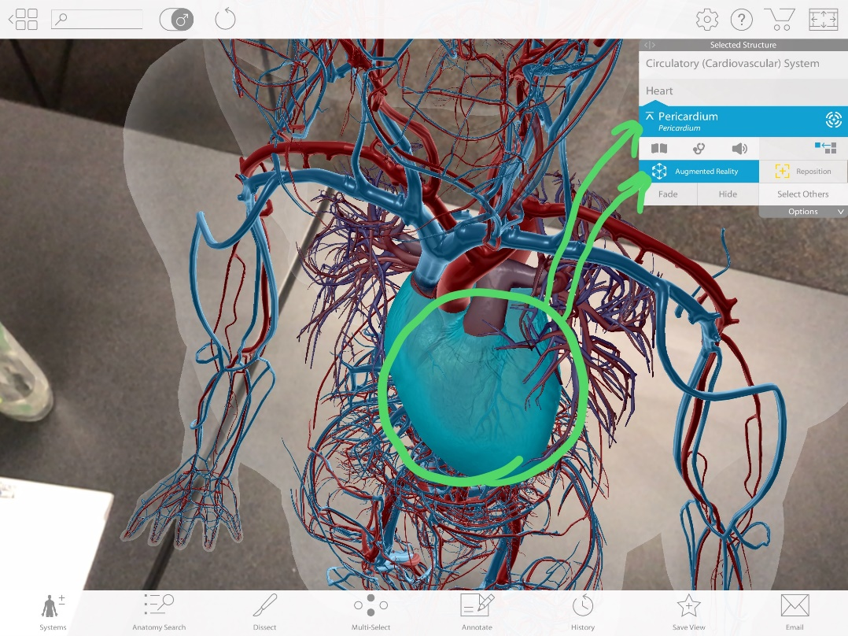
To exit Augmented Reality mode simply touch the Augmented reality box and it will exit you to the normal chosen view.
